**1.Renew it**

A graduate in Electronics Engineering from REC Surat, Mukund B.S has done his Post-Graduation in management studies from the Indian Institute of Management, Calcutta. Mukund worked in the Marketing team of Aashirvaad in ITC Foods, and was a part of the core team being instrumental in Aashirvaad Atta becoming the undisputed market leader in most geographies across the country. During his stint at ITC, he was inspired by the “Triple Bottom Line” philosophy and was keen to start off a venture which could create a Triple Bottom Line impact.

Mukund is also the Secretary-Treasurer of the IIM-Calcutta Alumni – Bangalore chapter and actively manages the Alumni e-group. Apart from this, Mukund is actively involved with social causes and works very closely with AMBA CEEIC, an organization established to holistically empower the intellectually challenged community through Economic Empowerment. He is keen to enhance learning through technology in education to bridge the digital divide in rural schools.

Raghav is a graduate from Western Michigan University and MBA from Manchester Business School. Equipped with the foreign exposure, Raghav wanted to build a successful business in India. He returned to India and successfully grew a pharmaceutical CMO for a couple of years.

During his stint, when he was upgrading his IT infrastructure, he saw that the way the computers were being disposed could be vastly improved and ended up co-founding **[ReNew IT](http://renewit.in/" \t "_blank)** with Mukund.

Raghav is a keen Networker. He is the founding member and has been on the leadership role of BNI – Ultimate Chapter. He actively mentors and contributes to the growth of the entrepreneurs of the Chapter.

In this exclusive conversation with Life Beyond Numbers, Mukund shares his journey with ReNew IT, their mission, challenges they faced, their learning and much more…

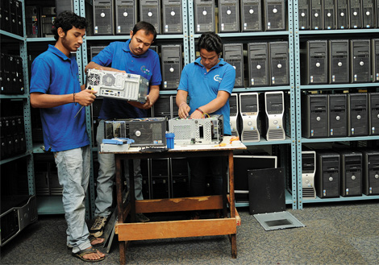

Inception of ReNewIT

While working at ITC, I bumped into a family friend Shiva Nanda – founder, MD Newport Computers. Newport is in the IT asset recovery and spares business. What they did was buy back used IT equipment and part it out to supply spare parts to companies which do maintenance and support. This was pretty interesting and if tweaked around in the Indian context could be a solution to the large digital divide in India.

Just to be sure if this was something that I really wanted to do, I quit my job and flew to the US, spent a month at Newport Computers and worked on their shop floor before coming back to India to start off ReNewIT. Newport Computers gave the initial support and hand-holding for a period of two years. In mature markets like the US and Europe, the IT penetration is close to 100%. As per the Census 2011 data, India has an IT penetration of 9.5% at a household level. This means that less than 1 in every 10 households own a computer. In China, the penetration is more than 30%. For India as a country to progress further – it is important for everyone to have better access to computers. It is well documented how the spread of mobile phones has benefited all of us.

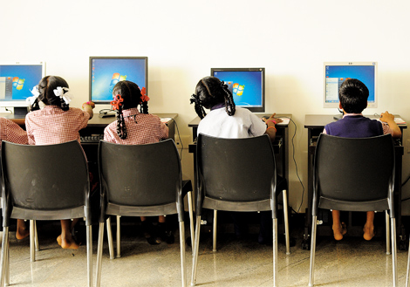

The technology has reached a level of maturity where 7-8 year old IT products are still extremely usable for day to day activities like internet browsing, email, use of basic software applications like Tally, MS Office, etc. This combined with the increase in the average purchasing power of Indians is a perfect setting for the explosion in the PC penetration in India. The main hindrance is the question of affordability and that’s the gap/opportunity we are trying to address.

### What is ReNewIT

The mission of our organization is to “**Make Computers affordable for everyone**“. We are doing this by increasing the number of **high-quality**, **low-cost** PCs and related parts and accessories available to Small Businesses, Students, NGOs and other users. To speak for our quality, we are an ISO 9001, ISO 14001 and OHSAS 18001 certified organization. We mainly source computers from large MNCs – refurbish and remarket them. This helps bridge the large digital divide that exists in a country of over a billion people. **We are one of the few Microsoft Registered Refurbishers and provide original Microsoft licenses at a fraction of the commercial cost to NGOs and schools along with our refurbished assets.** We are bootstrapped at the moment – funded by friends and family.

We have sold over 10,000 Affordable Computers over the last five years. Many of our customers are still using them. We sell computers starting from Rs. 4,500 onwards. We have sold computers to people from all walks of life – NGOs, educational institutions, SMEs, students, graphic designers, RJs, doctors, teachers, etc.

Many of our customers are first time computer buyers. They just know that they want to buy a computer. Many come to us and say, “Well, I want a computer” and that’s it. Our team educates them as to what would be the ideal configuration for them to purchase based on their needs and budget. Most of our customers refer us to their friends and family because of our unmatched warranty and after sales support.

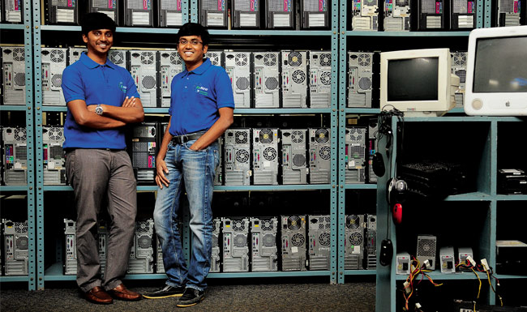

### The Way Ahead

We have just started our operations in Hyderabad and are in the midst of setting up in Mumbai. **We want to be present in all the million plus population cities of India.** Though the PC market globally is declining with the advent of tabs, phones and laptops, the Indian market is highly underserved. Less than 1 in 10 households and less than 1 in 20 offices have a computer. At the end of the day phablets are consumption and entertainment devices and computers are still needed for various activities like accounting for offices, project work for students, etc.

Our aim is become a Dell, HP or Lenovo for refurbished IT equipment. To provide high-quality, low cost IT equipment which is truly affordable for the average Indian and follow it up with good after sales support.

### The Challenges

There have been different challenges from the day we started on this journey. It is not very easy to start any business in India. **It took us more than a year to get all the required approvals from various government bodies since we didn’t want to pay any bribes.**Once we had all the approvals, in the initial days – sourcing was a big challenge. It took some time for people to understand what we were trying to accomplish. Then there were all the comparisons with us being similar to kabadiwalas. It takes time for people’s mindsets to change. Now people understand what we do and a lot of our business has grown because of referrals from satisfied customers who have referred us to their families and friends. We even have some customers who have bought from us and are using these devices abroad.

### The Learning

We work very closely with many NGOs to assist them with their IT needs. Most of them are doing amazing work and they are always crunched for finances. One of the NGOs we support is AMBA, where they train mentally handicapped children to do basic work like data entry, so that they can earn a livelihood and live a dignified life.

When we helped them with their laptop needs, the excitement on their faces when they started working on laptops and the kind of appreciation that I got from the students present was really heart-warming. I knew that I had positively impacted their life. Our aim is to reach out to as many NGOs as possible to help them do more of their amazing work.

As I have already mentioned, many of our consumers are first time users of computers and would have not had the access to IT if there was no option of a refurbished IT equipment. Buying a computer is a big milestone for our customers, and so many of them don’t buy computers on a Tuesday or during Rahu kala, etc. And after buying the computers, there is tremendous joy on the faces on the kids buying their first computers.

The main thing for any entrepreneur is perseverance. **Entrepreneurship is not a sprint, it is a marathon. The only way you can play this game is to love it and live it.** The aim should be more than just to make money. Money is always the by-product of doing the right things.

# 2. These IITians need your help to manufacture school notebooks for just Rs 5/-

India has a huge potential as a market. With over 60% of the population under the age of 25 years, a big part of our population is still in schools and colleges. Access to education is one part but giving them cheap stationary is often another neglected part of the equation. To solve this problem, Shubham Aggarwal and Anubhav Goyal started Adister during their stay at IIT Roorkee. [Here is what we wrote](https://yourstory.com/2013/07/how-2-iit-roorkee-grads-are-making-money-selling-low-cost-notebooks-the-adister-story/) about them earlier.

They bring the cost of notebooks down by placing advertisements on them.  They have managed to bring the costs down by 50% and in some cases over 50%; and it is still a profitable model. Shubham Aggarwal, Co-founder of Adister, said, ***"In our first edition, we could have given Rs.3 with every free notebook and we would have still earned a profit."***

When they started, they had to face a lot of challenges, but they had their own ways of navigating through them. Shubham talks to us about some of those challenges.

*"In the earlier days, the quotation for notebook manufacturing was very high and we thought of going to where the paper mills were located to get better quotes. It worked, and we were able to get much better prices.  The other challenge was people did not take us seriously, so we pretended that we were just young recruits who had a ‘big boss’ in the office! Yet another challenge was telling parents about this. We never told them until we got DISCO(Disciplinary committee) threatening notice from DOSW (Dean Of Students Welfare). Later we told them that it’s a “project”."*

Initially funded by B Plan competitions, Adister got seed funding from [Mrs. Nupur Panjabi](https://yourstory.com/2009/07/nupur-panjabi-founder-thehiringtool-com/) in July 2013 to start their operations. They are also raising money via crowd funding for the current edition of the notebook which is priced at Rs.18, while other notebooks of the same type (125 pages, spiral bind) come for around Rs. 30 to Rs. 50 in the market.  Initially, they gave the first version of the notebooks for free.

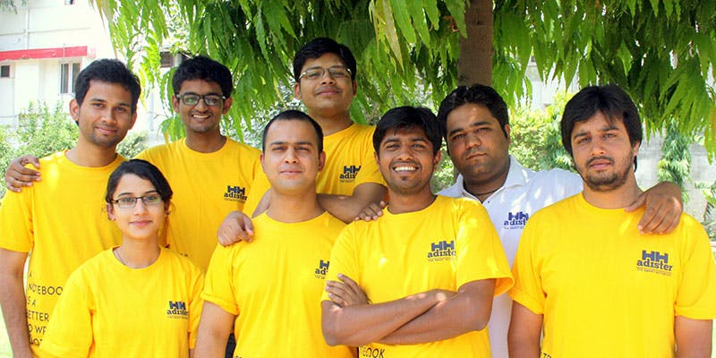Team Adister

After passing out from IIT Roorkee, they shifted their operations to Hyderabad but things didn't work out as planned and they had to move back to Delhi in December 2013.

**Crowdfunding campaign**

In the current edition, they are manufacturing over 10,000 notebooks. The best thing about this is ***that they have hired three differently-abled people to manufacture these notebooks.*** So far, over 15 people have contributed to the crowd funding campaign and they have raised a total sum of Rs. 48,500. Their total target for the campaign is Rs 3,00,000 and with this, they can then reduce the price of the notebook to Rs. 5 which in turn can be beneficial to the lower sections of the society.

At present, they have a team of five full-time members and four interns apart from three differently-abled people.

At present, they have a two-sided revenue model where they get sales revenue from notebook distributors and Ad revenue from the advertisers’ side. Looking at the demand and popularity of notebooks, Shubham says they get sold out within 2-3 days.

**3. Fin - wearable gesture control ring**

Rohildev.N has created a gesture control ring that uses interactions between the thumb and fingers to manage smart devices.

Different thumb and finger combinations can be used to control different devices through a Bluetooth connection. As the internet of things becomes more prevalent in our lives Fin is another option we will have for eliminating remote controls.

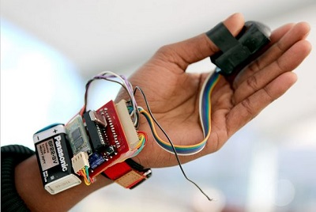  
<http://tctechcrunch2011.files.wordpress.com/2014/01/fin01.jpg?w=738>

When Fin is being used screens are one hundred percent visible, and when security is a concern Fin can control devices discreetly from inside a pocket or jacket. When driving a user can control automotive devices or smartphones without taking their eyes off of the road.

Operations work through an optical sensor in the ring. Fin detects the swipes and taps across your hand and sends the signals to a devices that takes in the output signal. Future plans call for biometrics to delineate between different parts of the finger, adding more controls to the mix.

Rohildev and his company, RHL Vision, were showcased at the [TechCrunch Hardware Battlefield](http://techcrunch.com/events/hardware-battlefield-2013/) at the 2014 Consumer Electronics Show. Fin was successfully [crowdfunded through indiegogo](http://www.indiegogo.com/projects/fin-wearable-ring-make-your-palm-as-numeric-keypad-and-gesture-interface) in early 2014 and preorders are being taken through the [website](http://www.wearfin.com/) at a $120 price.

The indiegogo video and website video share a lot of footage, and the examples come rapid fire. Joggers, drivers, gamers and head mounted device users are all shown using the Fin. Giving a presentation is shown with the Fin acting as the remote control, and the uses for physically challenged people are explored.

The Fin device is amazing, and the company looks to be full of engineers, makers and entrepreneurs who will bring the company's products to market. Based in Karala, India the company also operates out of Fin Robotics Inc in Palo Alto, California. The website doesn't have an official release date beyond "coming soon" but September 2014 is the date given on the indiegogo page for production of the first units.

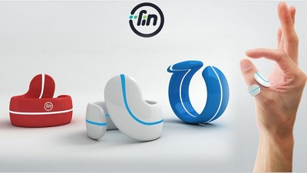  
<http://www.wearfin.com/>

# 4. Meet the 14-year-old coder who has coded 22 apps, right from healthtech to women empowerment

Contrary to what you may think, a genius isn’t always the product of the availability of world-class education, state-of-the-art equipment and rigorous training – more often than not, he or she may be born out of circumstances that exhibit a dearth and banality, and pose an opportunity to build and overcome. That is the story of Naman Tiwari, the 14-year-old self-learned app developer [from the small UP city](https://yourstory.com/2016/04/ankur-mishra/)of Shahjahanpur, who has coded 22 apps of a mind-boggling range.

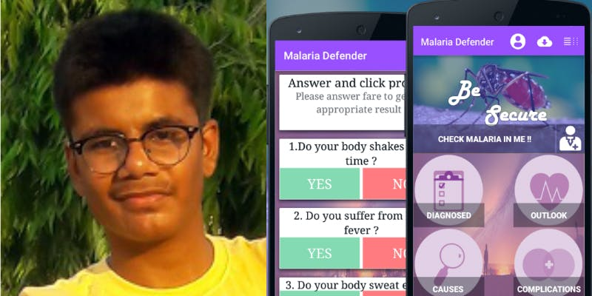

“I started learning about development technology about three years ago. [No one knows about Android development](https://yourstory.com/2016/05/app-developers-new-market-tips/)here, so I work alone and find it a bit difficult.”Naman doesn't have access to any fancy devices, in fact, here’s some trivia on the young whiz kid‑ he does not even own a mobile phone!“I just have a laptop and internet.I haven’t joined any tuitions or classes. I have coined a saying, ‘Don't ask for more until you make the best use of the things you have.’"

## ****Backward is ‘code’ for unrealised****

A student of Takshashila Public School, Naman started coding [when he was in the 7th standard](https://yourstory.com/2016/03/ihavereadthebook/), aged 11. “I picked it as a hobby because I thought it is the only way through which I can solve real world problems without a multi-billion dollar startup. I made many entertainment apps, but after seeing the problems in the medical industry in our country, I shifted from entertainment to social awareness apps.”

Besides the internet, his uncle mentors him through his journey of self-exploration. Patiently and relentlessly, he kept at it ‑ creating apps that were entertaining and useful all the same - and that range is mind-boggling. Straight from his brewery are apps like the AiO Converter that converts units in seconds with a few clicks, or the app that helps one swiftly calculate tips at a hotel. One is a trivia app loaded with fun facts, and another’s a tool that helps measure the frequency of your voice in decibels. There’s one to help children with their cognition of colours or even learn state capitals in the United States. Or, how about the one that provides sample interview questions to aspiring developers to make them job ready?

He even whipped up some [educational apps](http://her.yourstory.com/sukhada-tendulkar-0623), like “HTML Cool Learn” that helps developers learn HTML language with examples of webpages, or the one that helps kids learn all about the solar system. Another one of his concoctions helps Spanish connoisseurs learn the language, or Audiophiles learn any song by looping or selecting any part of it, and one that helps toddlers learn alphabets. Another app facilitates education, by helping school children organise the notes they make on their subjects.

The l[ittle genius](http://social.yourstory.com/2016/04/siddu-loute/)also combined his imagination with his skill to code some games, like Man Pong Fight, Maths Quiz, Tic Tac Toe (Classic), Vector War – or Shahrukh Man Pro, a guilty pleasure for SRK fans.

## ****The ones that were more than seven-day wonders****

But he has favourites, the ones that gave him a much more triumphant sense of eureka, are the two apps that are achieving the purpose that he got into app development for in the first place - Malaria Defender and Secure Girls.

His most complex and popular application Malaria Defender is an app that helps detect malaria in seconds, and Secure Girls is an app for women’s safety. On average, he takes about three to four days to code an app, but "Malaria Defender" warranted a month’s research and development.

“My most successful app is malaria defender, as it is solving a real world problem.It takes just few seconds to check the symptoms of malaria in a person and gives them a prescribed health report. It is ane-solution for those who cannot afford the doctor’s fees – and I designed it in a way that it can even work offline.” A user can also get a doctor’s advice through the app. Malaria Defender got selected in the Facebook Start Bootstrap Programmme, and Naman was awarded Rs33,000 in Facebook ad credit.

[Secure Girls](http://her.yourstory.com/safecity-1215)provides important helpline information, a panic button which can be used to send an emergency message, and is otherwise loaded with the latest news and motivational quotes and sayings.

## ****(Na)Man with a Plan****

He has never worked for a client professionally, though. “Currently, I make apps for people to entertain. I work as a public developer. I don't want to get bounded by a personal client, I will have a lot of time to do that later. I am too young, so I work for my passion.”

All his apps are live on Google PlayStore, under his publisher name "Naman Tiwari Spn". Overall, he has about 2,500users on all his apps collectively, “without even spending a dollar on marketing.”

Naman has found his ultimate calling even for the future, and surely enough, [it is tech](http://her.yourstory.com/empower-0623). “In the future, I want to create something bigger and more impactful so that people could remember me even after my death.  I want to become a successful entrepreneur and want to run my own software company,” concludes Naman.

# 5. This 13-year-old from Haryana has built a fully-functional solar bike

This 13-year-old from Haryana has proved that age is just a number by building a solar bike. While the country is struggling with ever-increasing air pollution and the Supreme Court has laid guidelines for its prevention, Avneet has designed a fully-functional solar bike that works entirely on solar energy.

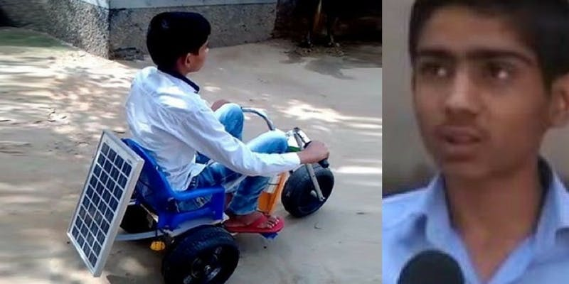Image Source: Social Media (L); [YouTube](https://www.youtube.com/watch?v=E-d0egI0D9c)(R)

With the multitude of problems originating due to air pollution, the time has come to forego conventional sources of energy such as fuel and move towards renewable sources of energy. The renewable solar energy is being touted as the alternative source. Many scientists and researchers are working towards utilising solar energy to the maximum, and many of them have also been successful.

The solar bike designed by this young boy runs at 20 kilometres per hour. Avneet reiterates the eco-friendly aspect of the solar bike as it does not emit smoke, and, therefore, will not cause pollution. This emission-free innovation can give a tough competition to battery-driven vehicles.

Avneet used a bicycle for kids to build this solar bike by installing a solar panel on it which derives power to push the bike forward. In its nascent stage at present, the bike is a one-seater. However, as it utilises solar energy, it will also prove to be economical as one will not have to spend on fuel such as petrol on a regular basis.

Avneet dreams to build a solar car in the future, which he believes will be less expensive when compared to even a Tata Nano car. Meanwhile, it is said that scientists have also developed a bike which runs on solar energy and will soon be available in the markets.

# 6. 16-year-old Kalyani Shrivastava from Jhansi built a cheapest AC in India for just Rs 1,800

These days it is not uncommon to see children nurturing their passion and fulfilling their dreams. This story is about 16-year-old Kalyani Shrivastava from Jhansi, who recently built an air conditioner for just Rs 1,800. She is studying in 12th standard at Lokamanya Tilak Inter College in Jhansi. Her father Dinesh Shrivastava is a teacher in the Department of Basic Educatio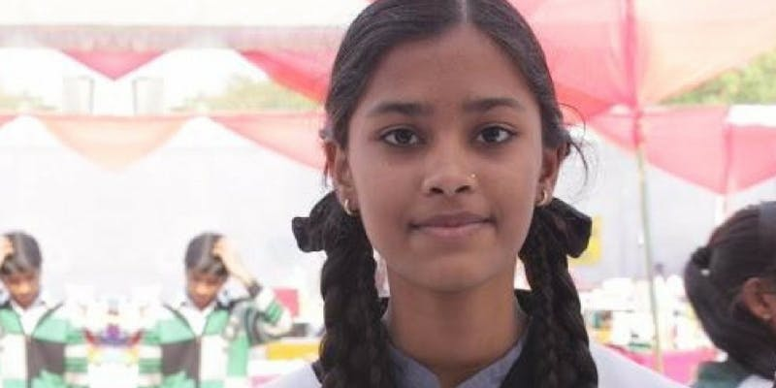n and her mother Divya Shrivastava is also a teacher.

Desi AC built by Kalyani has an ice box made of thermocol where air is released from a 12 volt DC fan. Cool air is then released from the elbow, which results in a drop in temperature by 4-5 degrees if the AC is used for an hour. This AC has been constructed in such a way that it causes no pollution.

Kalyani's AC has been selected by Indian Institute of Delhi (IIT-D) for the National Level Model Competition. Last year, she was honoured as part of the initiative 'Naari Samman' launched by the Uttar Pradesh government in partnership with Hindi newspaper Amar Ujala. She was felicitated along with other women who had excelled in sports, education, art, and social work. After looking at her work, she also received an invitation from the government of Japan for a seminar.

Along with excelling at science, she is also a really good singer. She has participated in the television reality show Indian Idol, reaching the third round. She has won more than 50 prizes in competitions held in Lucknow, Agra, and Kanpur.

This low-cost AC comes as a relief to the poverty-stricken population. Since the AC works on solar energy, it will not cause electricity bills to soar. The 16-year-old's invention is not harmful to the environment, either.

# 7. This 15-year old invented a garbage-collecting device to help clean his school

Sikanto Mandal was a ninth grader when he conceptualised and designed his unique ‘swachhta cart’.

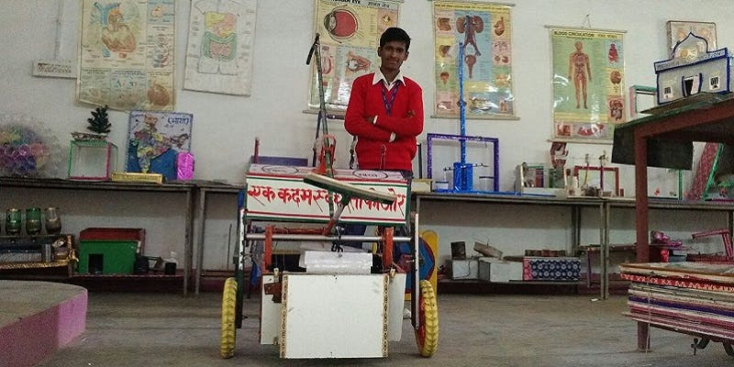

Sikanto Mandal’s early morning duties at school were a little different from that of other children who indulge in prayer and lessons. At the Jai Gurudev Sanstha School in Mathura, which provides subsidised education to underprivileged children, Sikanto and his classmates first cleaned their school premises.

## ****A real childhood challenge****

**Usually girls swept the ground and boys collected the garbage and then dumped it. I observed how many of my friends hesitated to touch and lift the garbage with their bare hands. This set me thinking and urged me to innovate something that would solve our garbage collection woes, says Sikanto.**

Sikanto then pitched the initial idea to his school teachers who further encouraged him to apply for the Inspire Awards. “To my surprise, my entry was selected and a sum of Rs 5,000 was transferred to my account to build my garbage-collecting device,” Sikanto adds.



The 15-year-old then spent one and a half months to construct his first elementary model of the manual, mobile garbage-collecting device. Designed after lots of trial and error, the initial model was mostly built using wooden parts from old furniture, bicycle brakes, chains, and other waste materials.

## ****Convenience is the differentiator****

When questioned how his innovation differs from other existing garbage carts, Sikanto enthusiastically explains:

**All the other devices in the market are mechanical and are run either on battery or fuel. My cart is completely manual, light-weight, and easy to operate.**

Sikanto’s mobile garbage-collecting device (for which he now holds patent) comes with simple yet unique fittings — a picker that aids in collecting garbage without touching it, a gripper and a handle which upon operating helps in easy dumping of the garbage without having to completely topple the cart.

**I have also provided customised spaces in the cart where people collecting garbage can keep the broom, a water bottle and other waste materials they might pick on their way, adds the enterprising teenager.**

These added special features makes the cart ideal for use by municipal workers who toil hard to collect garbage in urban spaces such as parks, schools, etc.

## ****Recognition and support****

First exhibited at the district level of the Inspire Awards, Sikanto’s garbage-collecting model won several accolades and was also selected for display at the state and national level. “In 2016, I exhibited my model at the National level in Delhi as one among the three entries from Uttar Pradesh,” says Sikanto, whose innovation at the event was recognised and appreciated by the then Science and Technology Minister, and the National Innovation Foundation (NIF).

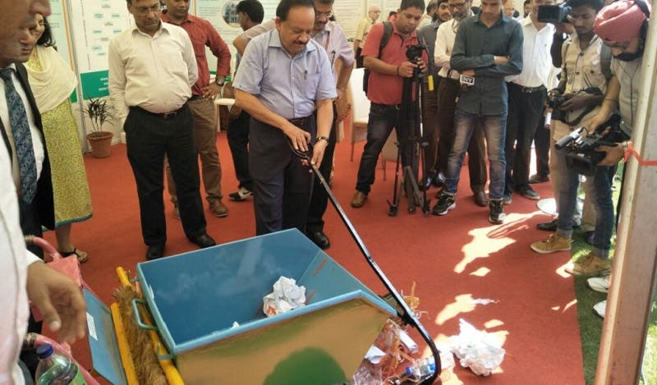

NIF then helped Sikanto build a proper prototype (made of metal) of his product and market it to potential enterprises. The technology behind mobile waste-collecting device is now transferred to Sarjan Innovators Pvt Ltd, a Gujarat-based startup. "We are keen on beginning the mass production of this device soon", says Gaurav Acharya, an entrepreneur who has acquired patents for commercialising the cart.

**The Swachhta cart enables a very professional way of garbage collection with a certain ease of labour in reduced time, he adds.**

Gaurav has supplemented the original model with a few more convenient modifications and has already piloted and checked the efficiency of the cart in the city of Patan in Northern Gujarat. Priced at Rs 10,500, the Swachhta cart will soon roll out into municipalities of other cities across India, promising to boost the Swachh Bharat Abhiyan.

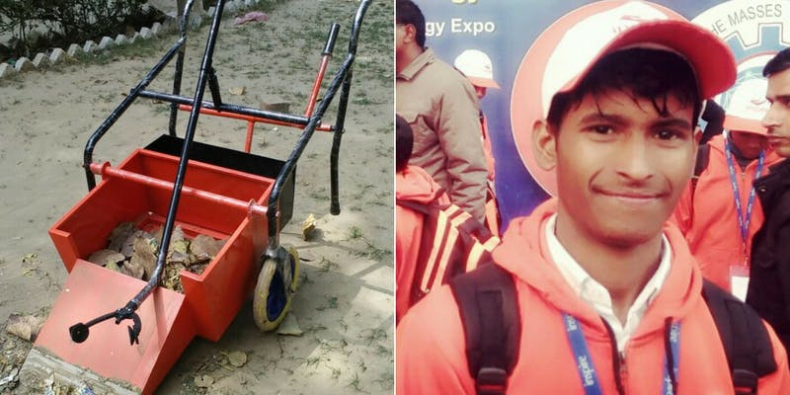

This socially-relevant design was exhibited at the week-long Festival of Innovation 2017 held at Rashtrapati Bhavan in March last year. Sikanto was also the youngest innovator to participate in the recently concluded ‘Innovation Conclave’ conducted by NIF to celebrate and encourage grassroots innovators.

Hailing from a family of migrants who moved to Uttar Pradesh from Kodla village in West Bengal, Sikanto aspires to become an engineer who innovates hatke(unique) machines in future. Having fought poverty and difficult circumstances in life, Mathura’s young innovator also has big dreams for his family.

# 8. This 15-year-old from Bengaluru uses age-old techniques to fight cancer, Alzheimer's

An enterprising teenager, **[Samay Godika](https://www.facebook.com/BreakthroughPrize/videos/1908262625865751/?fref=gs&dti=1294813663913040&hc_location=group" \t "_blank)**, is all set to represent India at a global competition. With his video on — a self-cleansing mechanism which could help fight dreaded diseases like cancer, Alzheimer’s, Parkinson’s — the Bengaluru lad is headed to put India on the global map. Samay is one of the 30 semi-finalists chosen from more than 8,000 of entries from across the world for the [**Breakthrough Junior Challenge**](https://www.facebook.com/BreakthroughPrize/videos/1908262625865751/?fref=gs&dti=1294813663913040&hc_location=group). The winner will be awarded the prestigious scholarship prize money in a glittering ceremony in Los Angeles, attended by the A-listers of Hollywood and the Silicon Valley.



An annual global competition sponsored by the founders of Facebook, Google and Khan Academy, the objective of the Breakthrough Junior Challenge is to inspire creative thinking in the field of science.

## ****Finding inspiration at home****

Samay, who was born in Boston, is a student in Class X at the National Public School. While students at his age find it difficult to manage exams and assignments, this teenager took inspiration from his own family to do something remarkable at such a young age.

Speaking about it, he says

**A few relatives in my family suffer from neurological diseases. This inspired me to do research about preventions. This is how I came across the topic — Autophagy. It is a process which occurs inside our body, which breaks down dead and decaying organelles, and converts them to energy. If Autophagy is executed regularly, it can have the power to prevent (not cure, just prevent) diseases such as Cancer and Alzheimer’s.**

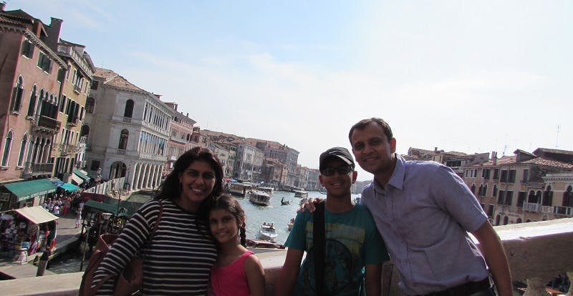Samay with his parents and younger sister

## Fueling****the engine****

As an avid science enthusiast and a youtuber, Samay created a video that depicted Autophagy. Autophagy is the science behind fasting. The discoveries of the mechanisms of Autophagy also won Yoshinori Ohsumi a Nobel prize in 2016. In his video, Samay explains the biological process through a clever combination of humorous animated story telling and informative scientific explanations. He says,

**I am really passionate about science, and I took up the challenge. The only round before the semi-finals was the Peer-to-Peer Review, where the participants themselves reviewed other submissions.**

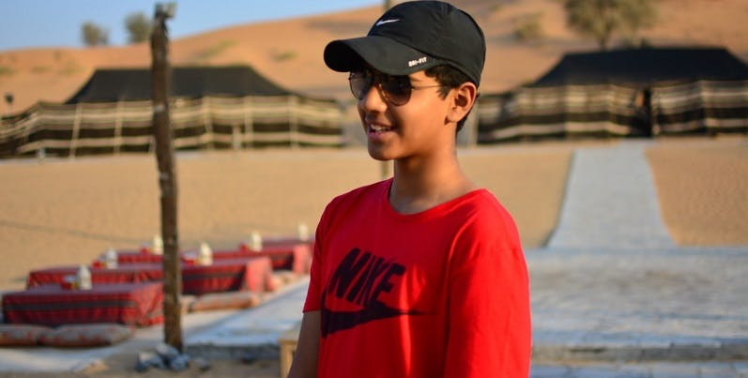

The video which was a stop-motion compilation, depicts Autophagy as a superhero. The [Breakthrough Challenge](https://www.facebook.com/BreakthroughPrize/videos/1908262625865751/?fref=gs&dti=1294813663913040&hc_location=group) which judged every video’s engagement, creativity, illumination and difficulty, has shortlisted 30 best videos. The submissions are uploaded on the official Facebook page for the audience poll. Talking about Autophagy, Samay adds,

**In every culture, there is a tradition of intermittent fasting. Turns out, our forefathers were right after all! Intermittent fasting is very healthy, and it accelerates the rate of Autophagy as well.**

Samay was one among the 8,000 applicants who applied for the contest and the only Indian who got through. Students from the ages 13 to 18 from all across the world research, create and submit original videos on complex topics in the field of life sciences, physics, or mathematics.**Beyond the contest**

Samay has also been selected by the Massachusetts Institute of Technology (MIT) for their Launch Entrepreneurship Programme 2017. This experience has led him to cofound Memorably, a company which creates photobooks of grandchildren for their grandparents. With this, Samay has set his eyes on the $250,000 scholarship prize money. Not just that, if he wins the challenge, his school will also get $100,000 for a science lab. This feat will bring him an ultimate distinction of being the first Indian to win this challenge.

Speaking about the administration at the National Public School which is vouching for the young champion, he adds

**My school has been very supportive, with the teachers helping me in promoting my video for the Popular Vote, and even sending messages to the parents of other students, requesting that they vote for me.**

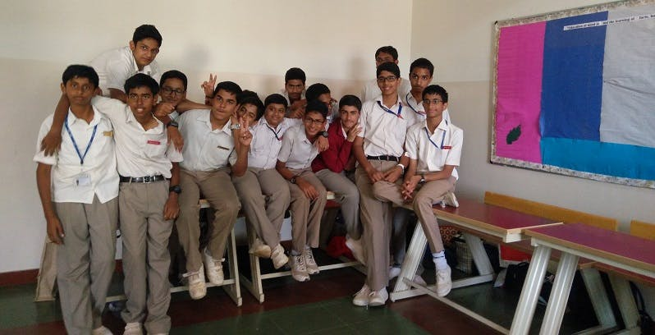

The young Youtuber has been garnering attention from leaders like Shashi Tharoor, Kris Gopalakrishnan and Minister of IT BT, Karnataka Priyank Kharge. They have been supporting him on Twitter. With only few days left for the public voting on Facebook to end, the teenager is quite ecstatic about the journey he has had so far.

# 9. This 20-year-old ‘Paperboy’ brings newspapers to you digitally

Available on the web and as an app, Paperboy provides easy access to a large number of newspapers and periodicals on a single platform.

With the [digital revolution](https://yourstory.com/tag/digital-india)and easy and inexpensive access to the internet, reading ‘on the go’ has almost become the norm. While most newspapers and periodicals are available online, reading them all on a single platform, at your convenience is what Paperboy is all about. Moreover, the app also lets you read them just as they are designed and printed – in the e-paper format, and hence, with all its glorious folds and tidy columns.

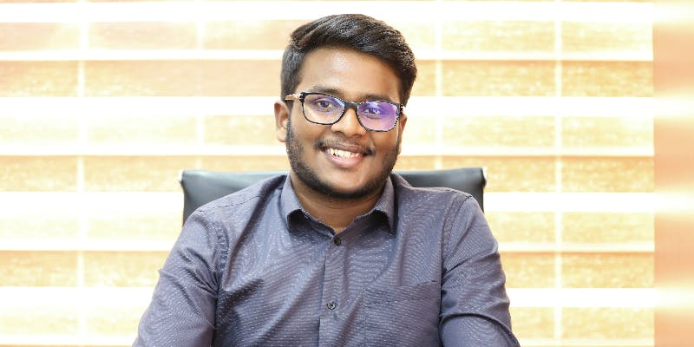Jonna Venkata Karthik Raja, the founder of Paperboy

## ****How the idea germinated****

Jonna Venkata Karthik Raja (20), the founder of Paperboy got cracking on the idea just 15 months ago – in February 2016 - but there was no particular brainwave that fuelled this plunge. “I love travelling as much as I love reading,” he says, adding, “but every time I [travelled](https://yourstory.com/tag/travel)to another corner of the world, I missed reading the newspaper. Even for the average reader, the only time they get to read the newspaper is while travelling or during meal schedules. My friends are sometimes clueless during discussions on current affairs because hectic school and college schedules gave them little time to read the newspaper in the morning. So when I asked them whether they would read the paper digitally, they all said yes. This gave me the impetus to start Paperboy,” he says.

## ****Taking the papers online****

In his final year at Bengaluru’s CMS-Jain University, for Karthik, finishing college and getting a job always seemed like the usual ‘stereotype’. “Does age really matter to entrepreneurship? Seeing my dad work on various business projects helped me build my entrepreneurial spirit early on,” he recounts.

“What if they don't take me seriously?” was my biggest fear,” says Karthik.

The doubts and fears did not deter him. He went on to build the app targeting those who prefer print media over digital media, featuring easily readable local and national e-papers of newspapers as well as magazines - accessible from any part of the world. Karthik explains that the interface on both the web page and the app is clean and simple, with no pop-up ads or interference. The app allows one to access news both online and offline.

The cloud-based platform is accessible from any device and lets one subscribe to daily print versions of newspapers online and free of cost, after which, they may also receive notifications for the same. Uniting newspapers into one application, Paperboy also aims to broaden the global readership base of [newspapers](https://yourstory.com/tag/journalism).

For now, e-papers that charge subscription are not on Paperboy. “Since Paperboy is a free application, one must simply register on the platform, and they can subscribe to all the newspapers on it,” explains Karthik.

**Something for everyone**

Since regional newspapers are its primary focus, Paperboy mainly targets Tier II and Tier III markets in India, and more specifically, the audience that avidly consumes regional news as well as those who already read and subscribe to e-papers. 3133 cities fall under this category, constituting almost 31.16 percent of India’s internet users.

“We are also targeting the Indian [diaspora](https://yourstory.com/tag/migrant-workers/), who would like to read their preferred local/regional papers,” he adds.

“This was a tedious task as we had to convince established media houses to feature on an app promoted by a (then) 19-year-old. While the idea resonated with many, it was very difficult to actually get publications on board. In fact, for the first six to seven months, there was absolutely no newspaper. Finally, the first newspaper featured on the app was Eesanje,” recounts Karthik.

Their biggest success so far has been the inclusion of Reader’s Digest on Paperboy. Currently, the app features over 300 newspapers and magazines, while the team behind this stellar growth has grown to 50 people.

## ****Early numbers****

The young team is aiming for at least one million active daily users in the first quarter of operation. They have not only hit the six lakh user mark but have also started generating revenues. “We work on an ad-revenue model. Our platform has non-intrusive strategic advertisement placements that do not disturb the reader in any way. While every ‘physical’ newspaper has ads, the same can be customised for the digital version too. This will not only increase revenues for both publishers and Paperboy but will give publishers an opportunity to go head-to-head with online news sources to secure advertisers,” Karthik explains.

They claim to receive one lakh unique visitors on the web daily, who spend eight minutes on an average there. Clocking approximately 11 thousand downloads each day, nearly 16.7 million pages are read collectively by this burgeoning user base.

Currently bootstrapped, Karthik is not looking for funding anytime soon. “We have attracted two investment propositions, but Paperboy has recently been launched, and we are yet to map any substantial profitability. I personally wish to focus on serving my customers at the moment,” he says.

While scores of content aggregators exist for online news and every news publication houses their own e-papers on their official websites, Karthik claims that there are no direct competitors for Paperboy, which directly brings all these e-papers on one destination. “There are portals that are primarily news aggregators that allow their subscribers to access news articles available online, or provide snapshots of an online news piece. Paperboy, on the other hand, is a newspaper and magazine aggregator that gives an online – real-time – print newspaper and magazine experience,” he says.

They also want to add as many prominent print newspapers and magazines as possible. In its second phase of development, Paperboy will expand its tie-ups to global newspapers from the [United States](https://yourstory.com/tag/united-states), the UAE, the [UK,](https://yourstory.com/tag/uk)and Singapore, before expanding to markets in other countries.

## ****After delivering your morning paper…****

Kathik juggles between college and work. A typical evening is spent brainstorming with his father on prospects for business development. “I dedicate my Sundays to family or to my absolute favourite pastime - flying. I currently have a student pilot licence,” he reveals, adding, “My passion for work, reading, and talking to new people are what keep me going.”

# 10. 12-year-old Kavya Vignesh and team are building a robot to save bees and need your support

Kavya Vignesh and her team are the youngest to represent India at a robotics competition in Denmark with their unique solution to save bees.

Kavya Vignesh, a class seven student of Delhi Public School, New Delhi, likes art, dance, and singing as much as she loves robotics. A good education is not just about [robotics](https://yourstory.com/2017/03/iblocks/amp/) or pursuing STEM; it's about doing everything that holds your attention and makes you curious and eager to learn more.

During one summer vacation, when Kavya was nine, her mother enrolled her in robotics classes with RoboClub and since then there has been no looking back. Kavya is 12 now, and her team Supercalifragilisticexpialidocious is India’s youngest ever to qualify for the First Lego League (FLL )-European Open Championship (EOC) that will be held in Denmark in May.

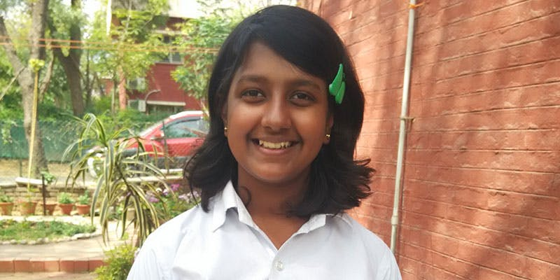Kavya Vignesh

Though the team's name Supercalifragilisticexpialidocious is a mouthful, it rolls of Kavya’s tongue easily. “The name was suggested as a joke but somehow stuck and to keep the consistency we carried the legacy forward. It means simply awesome or amazing,” she says.

To compete in Denmark, the team needs money for their prototype, travel, and other expenses. Unlike other parents, Kavya's parents were supportive of [crowdfunding](https://yourstory.com/2016/04/crowdfunding-good-bad/) and hence she took the [crowdfunding route to raise money](https://www.fueladream.com/home/campaign/752)for the team.

## The First Lego League

Kavya and her team will be a part of the FLL, a [robotics](https://yourstory.com/tag/robotics/) competition where almost 200,000 children aged between 9 and 16 years from 60 countries will participate.

National competitions are held in each country. Winners from the national competition are selected for the international competition where teams from across the globe are pitted against each other. Kavya and her team made it to the top eight and were the youngest team on the list. Now, they will represent India at the FLL-EOC competition to be held in Denmark.

The team is made up of six students and two teachers. All are associated with the RoboClub of which Kavya has been a member since she was nine.

## Saving the bees

FLL introduces a scientific and real-world challenge for teams to focus and research on. The robotics part of the competition involves designing and programming [LEGO](https://yourstory.com/2014/05/lego-techie/) Mindstorms robots to complete tasks. The students work out solutions to the various problems they are given and then meet for regional tournaments to share knowledge, compare ideas, and display their robots.

The project that Kavya and her team are working on is called the Bee Saver Bot which removes bees safely and carefully without harming them or humans.

Kavya says,**“**Whenever people see a beehive in their houses, they call the pest controls and burn the hive. That kills about 20,000*-*80,000 bees. So we thought of building a solution that can safely relocate the beehive without harming the bees because more than 85 percent of the world’s crops are pollinated by honey bees. Every third bite of food comes from a [bee pollinated](https://yourstory.com/2015/08/bee-pollination-farmers/) crop or animal that depends on bee pollination.”

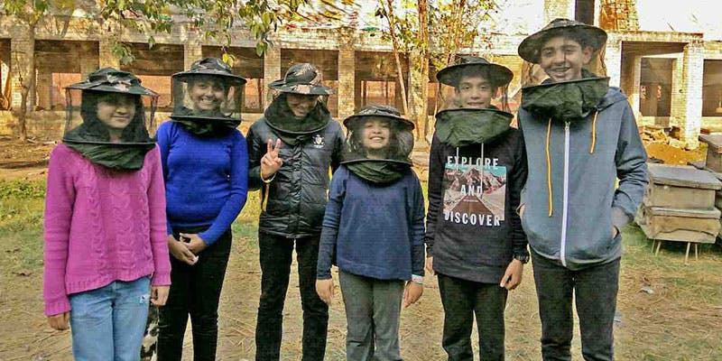Team Supercalifragilisticexpialidocious

As a part of research, the young team visited a bee keeping farm and training centre in Uttar Pradesh and learned [all about the bees](https://yourstory.com/2015/04/bee-the-change/) and built their Bee Saver Bot. The Bee Saver Bot takes down beehives without harming any humans or bees in households or high-rise buildings.

## The Bee Saver Bot

The prototype that they are working on and need to have ready for the competition in May is a quadcopter — a flying drone with a 3D camera which scans the hive and the area around it and gets 3D measurements. The measurements are then fed into a CAD-CAM software which designs the shape of the enclosure which is needed to cover the hive and the bees altogether. Kavya explains that the design is fed into a wood-based 3D printer, which prints a biodegradable, breathable, and reusable enclosure. The quadcopters go up again near the hive. Two arms enclose the hive completely, while a third arm uses a sharp blade to slice off the hive from near the wall and seal the enclosure. The enclosure is now transferred to a vehicle to be transported to the nearest bee farm.

Called the Lightning McQueen, this red colour robot will be built with Lego Mindstorms EV3.

Explains Kavya, **“**We are using EV3 large motors, colour sensors that are used for line following, gyro sensor to take accurate turns, and pneumatics for multi-tasking. The pneumatics are just like hydraulics, they store the air in them and then use it for various tasks. Our robot consists of simple mechanisms such as gear mechanisms, incline planes, and lever mechanisms. We did so to minimise the use of motors during the tasks."

She adds: "An example of one of our cool mechanisms is the food collecting mission. We have used a reciprocating mechanism – the robot leaves the base and an enclosure drops which traps the animals. Then, the robot aligns to the wall, reaches the refrigerator, and the reciprocating mechanism activates, collecting food in the same enclosure!”

Kavya has been working on this along with her school work. Initially, the team used to have a weekend session of two*-*four hours a week but as the competition gets closer, they practice five days and 18*-*24 hours a week on an average.

Her work has received attention from the government too.

# 11. This 16-year-old innovator has given the experience of sight to the visually impaired

Gursimran Singh, a 16-year-old class 12 student from Gurugram, has introduced the concept of ‘imagine or visualise’ in the lives of the sightless.

Sight. A one-syllable word, but a sense that perceives 80 percent of all impressions.

We interpret the world, its beauty, its dangers, with our eyes. Close them and we are in a world of endless darkness.

It is true that the blind do not miss what they never had. This doesn't mean we accept their state or our inability to help them. After all, nothing can exceed the joy and sense of fulfilment one experiences by giving someone something they never had.

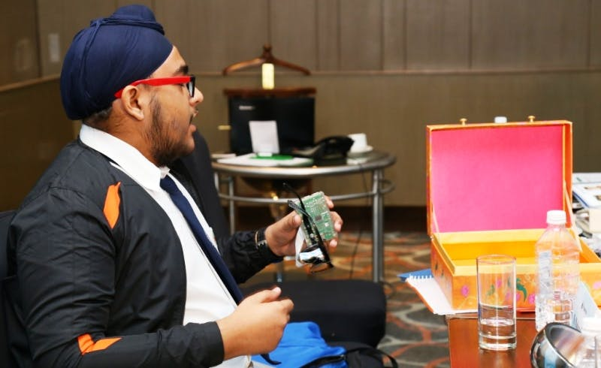

## Conception

Sixteen-year-old Gursimran Singh is the inventor of EyeScribe, an assistive device that helps the visually impaired experience the joy of reading. For Gursimran, the concept of EyeScribe evolved over a period of time—“I had a relative who was visually impaired. Seeing him struggle every day led me to an open-ended question: “If we can, why can't they?” and “if we can, then what should we?” he says. Gursimran started to work on his device in August 2016 and it took him almost three months to showcase it. It was first screened at the Atal Tinkering Lab Innovation Challenge by NITI Ayog in the FICCI Auditorium on November 5, 2016.

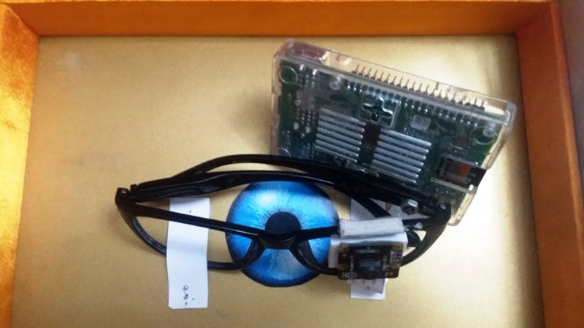

## Why EyeScribe?

EyeScribe is a type of wearable technology. It has an eight-megapixel camera fixed to the frame that enables the capturing of an image. Once the image is captured, it is processed to produce an audio output. “The process basically includes an optical character recognition followed by a machine learning algorithm for correction and accuracy which is finally worked upon by a text to speech engine,” Gursimran explains.

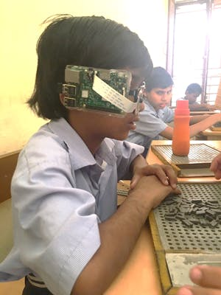The device gives the blind a 3D aural environment to create mental pictures while reading.

There's an abundance of braille devices in the market today. However, EyeScribe stands out as it nullifies the use of braille in itself.

Taking advantage of the fact that the blind have an enhanced sense of hearing, Gursimran has given them an easier alternative. “EyeScribe dictates the text, which means the text need not be in braille; it can be in any language. Also, currently, the resources available to the visually impaired are fewer than what others have, and the books printed in braille are voluminous. EyeScribe is a virtual solution and can be used across any text matter, regardless of it being in braille or not.”

He uses an example to explain the above, “Most of the newspapers, which are printed in braille, are published every fortnight. But with EyeScribe, a blind person can stay updated every day because he/she can now read the daily newspaper.” he says.

## Endurance in tougher times

During early screenings, EyeScribe lacked the required speed. This did not deter Gursimran's morale. “I had to re-plan the process to reduce its input-output duration. After a lot of research and consulting people in this field, I was finally successful in eliminating its speed as a drawback.”

Another hurdle sprung up when he visited blind schools to test his innovation. “The authorities were skeptical of the medical reliability of the device and so they did not allow me to visit. I then had to work with doctors and psychologists to validate that my device was fit to use.”

## Success through it all

Initial funding to develop the first prototype of EyeScribe came from Gursimran’s parents and which it won the ATL grant-in-aid of Rs 20 lakh. Also, NITI Aayog provided a makerspace to develop the device at a commercial level for distribution across the country.

It was declared the National Winner of the 2017 Pramerica Spirit of Community Awards, opening up a host of opportunities for the young talent. Gursimran considers his stay at Washington DC for the International PSCA honour as the most valuable week of his life. “I got to collaborate with people from eight different nations. It was an honour being felicitated by Michael Phelps, the most decorated Olympian, for my community service. It also brought my innovation to a national front. My dream of reaching every single blind person can now be fulfilled.” A monetary reward of Rs. 50,000 from the same helped expand his work.

Till date, Gursimran has successfully tested his device on 120 blind children between the ages of five to 10 years with a 98 percent success rate. “I am gradually expanding the base, and with each test, I know what needs to be improved and how it is to be done.”

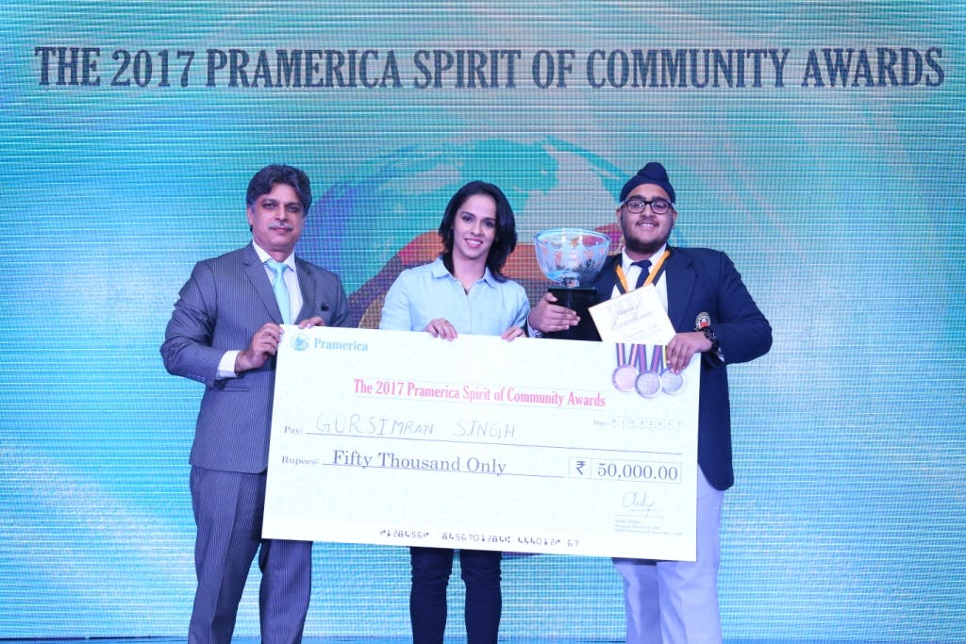

## Heading toward the future with a sense of purpose and gratitude

Speaking of lessons learned in this journey, Gursimran says, “It was a great learning experience—it taught me how to manage things, how to network with people, and how to face challenges. The people I have worked with primarily are the visually impaired themselves; they are the biggest source of inspiration for me.”

Now recognised on the national front, Gursimran is working toward a completely market-ready device. He then wishes to take EyeScribe through the ADIP Scheme (Assistance to Disabled Person for Purchase/Fitting of Aids and Appliances) functioned by the Department of Empowerment of Persons with Disabilities under the Ministry of Social Justice and Empowerment.

Credit: Zach Harrison

Gursimran feels confident about working in the field of assistive technology and biomedical engineering.

He says, “I have already started working on my next device. With the same vision, I have started a non-profit called The Code Initiative, a social campaign to "heal with technology." It aims at providing such services to those in need and spreading tech-awareness.”

EyeScribe was the first device under The Code Initiative and in ten years he wants to expand pan-India, reaching every person who needs it.

A man on a mission, Gursimran ends with an original quote for his readers, “Be curious, be humble, and always try to make your life memorable for others as well as yourself.”

# 12. This 15-year-old has built 8 apps and India's first social search engine

*Acting beyond his years, Abhik Saha is a living proof to the saying — age is nothing but a number. A full-fledged entrepreneur at 15, his actions still remain grounded while his initiative helps feed the hungry.*



Not treading the route of excuses or procrastination and not giving up in tough times, makes 15-year-old Abhik stand apart from his peers. Hailing from Chalsa, a nondescript small town in the Jalpaiguri district of West Bengal, he was an average student at Don Bosco English Medium School, Oodlabari, until 2011, when he got his hands on his first computer that changed his life completely.

Fighting the popular belief that one can achieve something great only if one belongs to the metropolis, Abhik began his journey of developing apps and creating his own search engine, all from his room in a small town.

## An early love for technology

Son of a school teacher, Shefali Saha, and Alok Saha, a plywood trader, Abhik is a tech wizard who became interested in programming when he was just an 11-year-old kid. He ventured into the world of coding soon after his first class on the principles of web design.

Although he was immensely interested in the new subject, he was the only student to fail the computer science test in the entire class that year. Demoralised, he still refused to give up on the subject and decided to study hard. “I did excellently well in the next computer science exams, this was a major boost,” he exclaims.

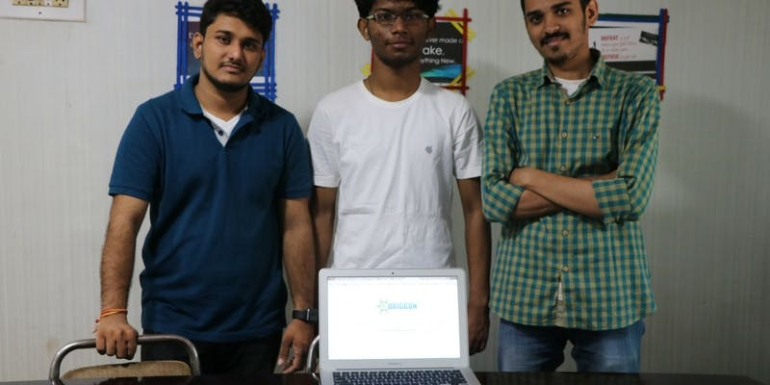

Abhik took an instant liking to web designing with a lesser focus on programming. “My teacher appreciated the effort I put into designing web pages but insisted I work on learning programming as well. To me, C++ and other programming languages were plain boring. But what followed is still a surprise to me.”

Since his understanding of programming was very poor, Abhik had nearly given up on learning the subject. He shares that his only saving grace was his chance meeting with a software developer who explained to him the importance of programming and its possibilities and also let him try Visual Studio, a programming integrated development environment for building software.

“I began studying programming seriously and improved my coding skills, and solved logical problems. I then knew this was the direction I wanted to take in my life.”

Abhik went ahead to found Arnabhik Corp, a website building firm with a help from friends of the same locality in April of 2014. He was only 13 then. Though the company was never formally registered, it generated good revenue and projects from international clients gave Abhik the opportunity to create over 30 websites. “With the company turning out to be a success, I decided to move forward,” he says.

## The next step forward

The money Abhik earned with his website building firm in 2014 helped him buy two computers for coding. He also bought his first server and a broadband connection. This marked the beginning of Abhik unlocking his skills.

He started out by building basic software utilities watching online tutorials, exploring and finding a solution to problems. He also built a security system and an antivirus that he named Seren to protect his school computers from viruses. His next milestone came in the form of a smartphone his father gifted him on his birthday in 2015. “With the smartphone, I understood that apps are the future and began learning app development for Android.”

After thorough self-training, hours of research and serious hunting for new ideas, Abhik created his first 2D Game App ‘Birdingo’ on November 2, 2015. This was followed by five other apps in quick succession: two education apps, Math++ and Abcd planet; a learning app, i-Learn, which gives free video tutorials on computer programming or developing languages; a 3D gaming app, 3D Task 24; and Arnabhik Website Builder, an app that helps people easily get a free hosting website.

2016 continued to be a successful year. On April 5, 2016, Abhik launched GreenCulture, an Agriculture App which notifies farmers of latest news about crops, lands and better farming techniques, providing scope for real-time chat with experts. Lastly, Reming God, a Reminder app that helps one remember plans made for the future went live on April 30, 2016.

## India’s own social search engine

Abhik began working on creating his own programming language called Lino after the launch of his apps in April 2016. “I did not see the need to rely on multiple languages to create technology, so I took up a project to invent a unified language. As I worked on understanding the frameworks that hold up the Internet, time and again my research hit a number of roadblocks.”

The problem wasn't the lack of good quality content while browsing websites but it was the amount of spam, fake sites, malware, irrelevant content and intrusive pop up ads that slowed down his research. He was most disappointed when keyword searches led to sites, with no relevant information, ranked on the first page by search engines.

Abhik realised that before he could change what the developers built for the Internet, he would have to change what users expect out of it. This triggered the launch of [Origgon](https://origgon.com/" \t "_blank), a search engine whose SEO won’t show you the top sites chosen on grounds of advertisements but the top searches chosen by people all over the world.



“The idea of launching a search engine came to my mind after I successfully created Lino. I began working on the assignment but was in need of funds. Around mid-February 2017, I met an angel investor via Facebook who invested Rs 21 lakh and helped me turn this project into an actual business,” says Abhik.

“My objective was to build an index and database of websites one by one. I wanted to make a search engine that extracts results from other search engines and algorithmically sorts the best, deletes the spam and malicious sites. Our main feature is, we do not track you or your IP, and you are completely anonymous while using our servers,” he adds. With this, Abhik shifted to Mumbai in April 2017 after clearing his board exams and launched Origgon in August both as India’s first social engine and a registered company.

## Contributing towards feeding the hungry

Origgon analyses little things such as likes, comments, shares to rank websites using real human signals. This unnoticed information brings more value, true and real content to the web, and in the process helps us discover a number of good sites that often get lost in the clutter and also get personal reviews, thereby helping us make easier decisions.

Moreover, the trust factor Origgon builds is most important. Abhik explains, “We help people trust the content they view as it has been either liked or shared by another viewer. Powered by Bing and social media, we are completely transparent. You can clearly see the likes, shares, and comments each result has, both globally and within your social media circles. You can further like and comment, creating a social media like environment on the search engine.”

The benefits of Origgon do not stop here. Using the engine will not only give you user-friendly results but you will also help Abhik’s cause to feed the hungry. The initiative started on the October 3, states that for every 5,000 searches it gets, the company will donate 10 kg of wheat flour to NGOs supporting mid-day meals. So for every 50 searches, you make through Origgon, a poor tummy gets full.

Today, Origgon’s team has just three members. They plan to raise funds to hire experts to build the next level of their search engine. Abhik signs off by saying, “My goal is to change the way sites are built and consumed. I want this to be an experience involving real reviews from real people like you and I. To achieve this, our aim is to upgrade Origgon by increasing the outreach of our business, expanding our servers and also improving our marketing and research and development. This would require a funding of about 7 million USD and we are looking for angel investors to help make an Indian search engine the best search engine in the world.”

With at least a million searches on Origgon for a start and by not limiting browsing to just the 10 blue links that appear on every screen, this passionate young entrepreneur wants to become the Bill Gates of India and give back to his nation through his startup.

*Anyone interested in funding the startup can contact Harshit Jain: harshit@origgon.com*

# 13. To avoid his mother's scolding, this 10-year-old invented an automatic mopping machine

[Shruti Kedia](https://yourstory.com/author/shruti-kedia)     posted on 12th January 2018

*To avoid getting an earful from his mother over spilled juice, 10-year-old Arman Gupta invented ‘The Mopping Machine’, a remote-controlled cleaning device for wet surfaces.*

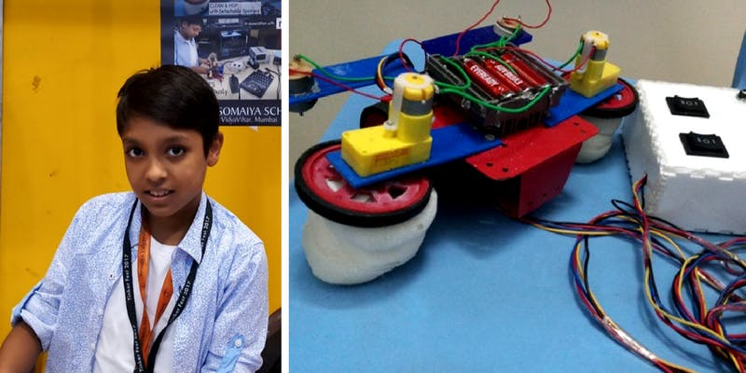

On spilling juice on the floor, how would you expect a 10-year old to react? Furtively cleaning up the mess or confessing and apologising are the two scenarios that come to mind. Young **Arman Gupta**, instead, was inspired. Playing a part similar to the apple in Sir Isaac Newton’s life, this incident got Arman thinking about the possibility of creating **a remote-controlled cleaning machine**.

**He tells me, “I got scared that my mother would scold me. I looked around for a vacuum cleaner and realised it is meant for dry dust — there was nothing for wet surfaces. This got me thinking.”**

And this was the beginning of Arman’s journey of innovation. Today, this **class-V student** has become the youngest innovator to showcase a creation at the Somaiya Research Innovation Incubation Design Laboratory (RIIDL’s) **‘Maker Mela’**in January this year.

## The journey

Arman has always been interested in **robotics** and his games involved **mechanics**, small toys with different devices. Looking at his enthusiasm, his parents Manishi and Nitin Gupta enrolled him in an **incubation design lab** situated in his school, Somaiya Vidyavihar, Mumbai.

**“During my Diwali holidays I was getting bored, so I would go the design lab and work there with the mentors at the incubation centre. I would spend the whole day there,” Arman explains.**

Post the holidays, Arman continued his visit to the centre after his classes.

A **typical day** for Arman begins with getting ready for school at 6 am, after finishing which at 3 pm, he visits incubation centre, working until 7 pm. Once back home, he studies for over an hour and a half, going to sleep latest by 9:30 pm. Further, he **devotes his weekends** completely to the**innovation centre**.

Not at all exhausted by all the work he puts in, Arman wishes to connect with investors when he has a more evolved machine on his hands.

**Presently, however, his biggest distraction and challenge is his six-year-old brother who breaks his “gadgets.”**

## The machine

Arman’s innovation, called **The Mopping Machine**, is designed to clean and simultaneously mop surfaces dry.

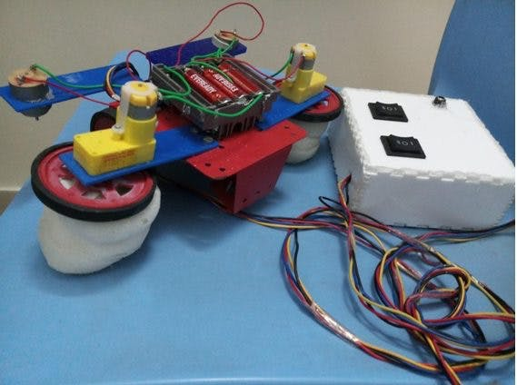

With **detachable sponges**, the machine can be customised for different surfaces — under the table, the floor, and corners. Further, the mobile nature of the machine makes maintenance easy.

**“This can be used as a mopping machine in every household, office, or even the streets. It can also play a vital role in Prime Minister Modi’s Swachh Bharat Abhiyan, and reduce manual labour,” he says.**

To understand the problems and challenges related to the manual work required in cleaning, Arman **spoke** to various**domestic helpers**. He began this project in November and completed it within a span of a month.

## The young inventor

Earlier, Arman has had the opportunity to showcase another invention at an exhibition in Kolkata, where he was among the **top five innovators**.

**Through Maker Mela, an event for grassroots innovators from India, Arman hopes to connect with potential investors and corporates who can help him scale his “basic” model and make his device a more “consumer durable product.”**

Innovators attending the Maker Mela range from **tech enthusiasts** to crafters, educators, engineers, artists, members from science clubs, students, and even commercial exhibitors. Arman is the **youngest innovator** there.

We wish the young lad the very best and look forward to seeing what the  scientist in the making comes up with next.

14. An Indian startup has developed smart shoes to help the visually impaired

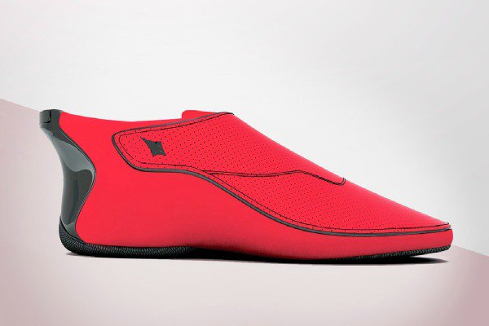

Image: YouTube capture/Lechal

Ducere Tech, an Indian startup that designs wearable technology, has developed interactive, vibrating footwear that helps users find directions. The new shoe technology is called [Lechal](http://lechal.com/accessibility.html" \t "_blank), which means “take me there” in Hindi.

First, the users must enter their destination in the Lechal app using Google Maps or another navigation app. Their smartphone then connects via Bluetooth with a small module located in the back of each shoe, near the heel. The right or left module will vibrate every time the users have to take a turn, pointing them in the right direction.

Its creators, Krispian Lawrence and Anirudh Sharm, developed the device aiming to improve the aids currently available to the visually impaired. They [told the Indian magazine *White Print*](http://lechal.com/blog/), which is printed in Braille, that Lechal is their attempt at developing a technology that can help visually impared people navigate unfamilar areas by providing vibrating cues that can tell them where take a turn. The new technology is designed to complement the white cane—the walking stick that blind people and those with severe vision loss use to travel independently.

Lawrence and Sharm—who hope their creation provides “people who are visually challenged the confidence to independently move around in familiar and unfamiliar areas”—have partnered with doctors from the LV Prasad Eye Institute in India to run clinical trials.

[Katie Nelson from Mashable](https://mashable.com/2014/07/29/smart-shoes-directions/) reports that Lechal will also be sold as a lifestyle product that can track the number of steps taken and calories burned. The shoes will cost about US$150, but the price could be lower for those who only want to buy the insole platforms, which can be adapted to any type of footwear. Nelson reports that the first orders will be shipped in March 2015.

# A 16-Year-Old From India Built a Device to Convert Breath Into Speech

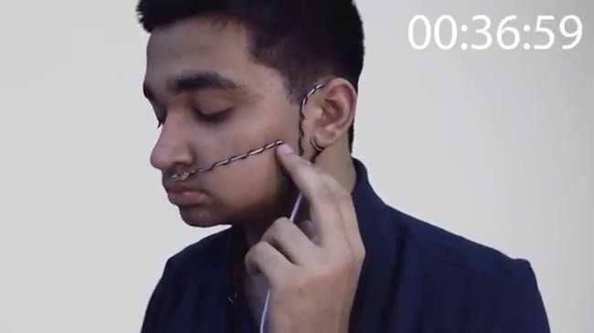

Image: YouTube

A 16-year-old from India [**has designed a device**](http://m.timesofindia.com/city/gurgaon/Panipat-teen-makes-device-to-turn-breath-into-words-enters-Google-science-fair/articleshow/42309727.cms) that converts breath into speech. High-school student Arsh Shah Dilbagi invented TALK as a portable and affordable way to aid people suffering from ALS, locked-in syndrome, and anyone else speech-impaired or paralyzed. Prototyped using a basic $25 Arduino microcontroller, Dilbagi's invention costs only $80, or about a hundred times less than the sort of Augmentative and Alternative Communication device used by Stephen Hawking.

TALK works by translating breath into electric signals using a MEMS Microphone, an advanced form of listeningtech that uses a diaphragm etched directly onto a silicon microchip. The user is expected to be able to give two distinguishable exhales, varying in intensity or time, so that they can spell words out using Morse code.

A microprocessor then interprets the breathes into dots and dashes, converting them into words. The words are then sent to a second microprocessor that synthesizes them into voice. The morse code can either be translated into English, or specific commands and phrases. The device features nine different voices varying in age and gender.   
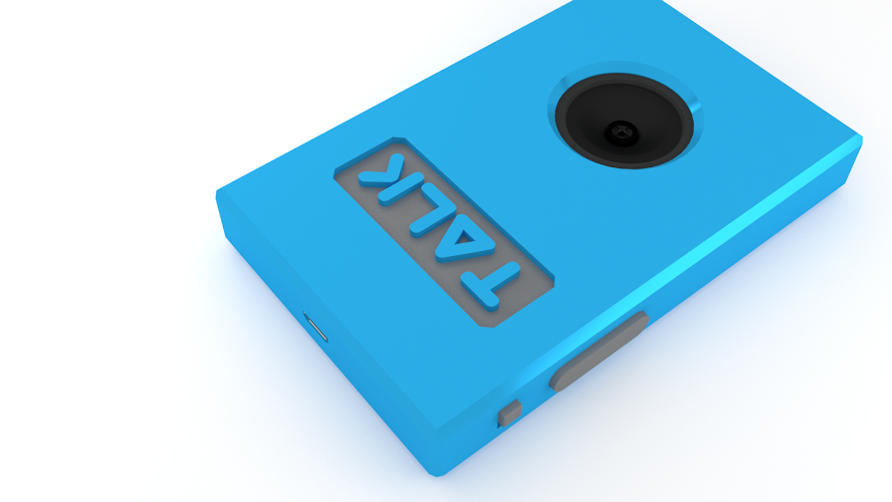

In his [**video**](https://www.youtube.com/watch?v=kwJ3uTXDpnU) explaining the device, Dilbagi (who prefers the nickname "Robo") notes that 1.4 percent of the population suffers from these sorts of disorders and they experience a lower life-expectancy in part due to lack of expression. With his affordable device, he has the potential to improve the lives of millions by giving them a means of communicating. [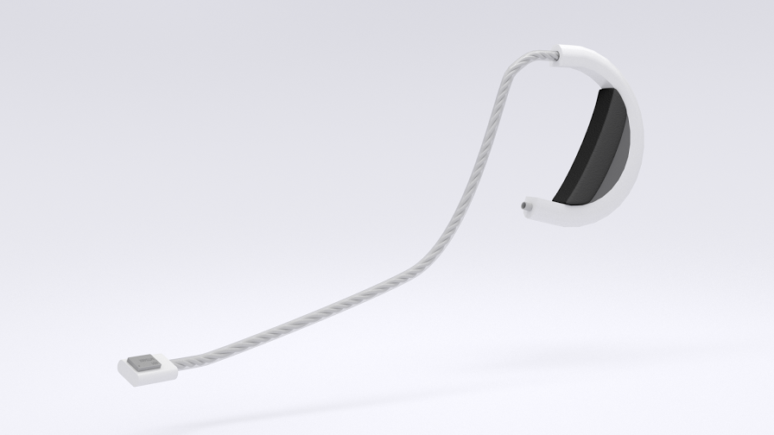](https://www.thebetterindia.com/wp-content/uploads/2014/07/talk_earclip.png)

"After testing the final design with myself and friends and family, I was able to arrange a meeting with the Head of Neurology at Sir Ganga Ram Hospital, New Delhi and tested TALK (under supervision of doctor and in controlled environment) with a person suffering from SEM and Parkinson's Disease," [**Robo wrote in his project report**](https://www.googlesciencefair.com/projects/en/2014/dde56de014edae3e9516ac84d426641f372ba076d6f6b60a4809306f43b58bc6). "The person was able to give two distinguishable signals using his breath and the device worked perfectly."

Dilbagi was the only finalist from Asia in [**Google's Global Science Fair**](https://www.googlesciencefair.com/en/), a competition open to 13 to 18 year old thinkers. Voting takes place online through today. Other projects submitted by teen geniuses include robots modeled after fruit flies; a new way to identify quasars; and an ultrasonic burner that reduces greenhouse gas emissions from car engines.

**15.  EDUCATION –**[**CARDBOARD BOXES TRANSFORMED INTO DESKS**](https://www.goodnet.org/articles/how-cardboard-boxes-are-transforming-education-in-india-video)

In rural India, resources are limited and schools are particularly affected. Most students do not have proper desks, making learning more difficult -contributing to poor eyesight and posture. Marketing company DDB India and the nonprofit [Aarambh](http://www.aarambh.org/" \t "_blank) came up with a creative solution called Help Desk. Made from discarded carton, [the cardboard desk doubles as a brief-case like school bag](https://www.youtube.com/watch?v=ZPUFpEbkOoc) and costs only 20 rupees to produce. The Help Desks are making significant difference in student’s lives and are easy to export to other countries in need.

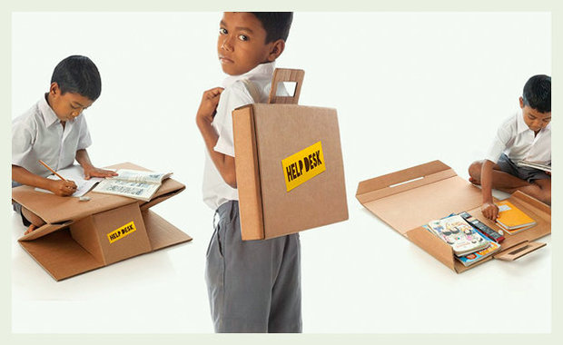

The multi-purpose recyclable desk. [[Screenshot](https://www.youtube.com/watch?v=ZPUFpEbkOoc)]

# 16. ‘Plastic is poor man’s friend’: Padma Shri winner Rajagopalan Vasudevan uses waste to build roads

## The ‘Plastic Man of India’ has found a way to reuse plastic waste and to make durable roads.

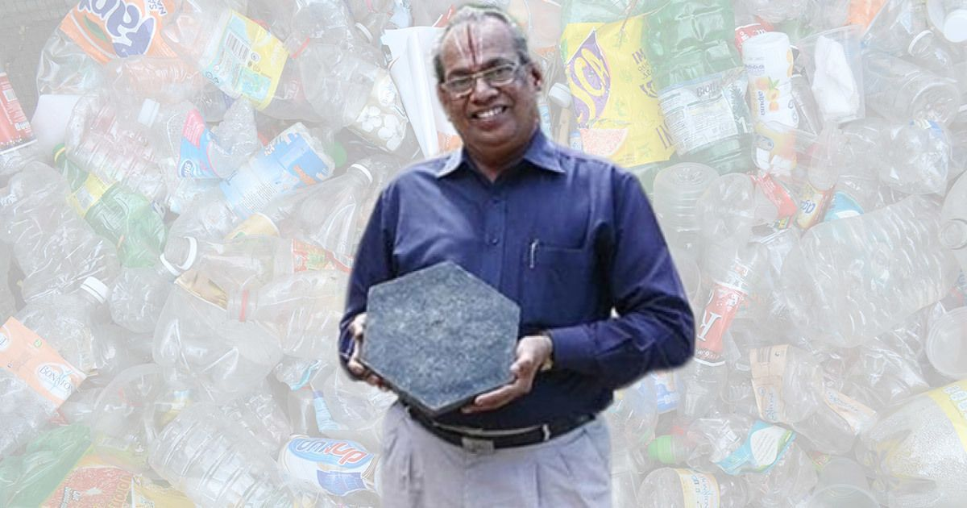

A 73-year-old retired chemistry professor from the Thiagarajar Engineering College in Madurai was on Thursday named as one of the 73 recipients of the Padma Shri, the government’s fourth highest civilian honour. Rajagopalan Vasudevan is known as the “Plastic Man of India” for devising an innovative way of disposing of plastic waste – by using it to build roads.

In 2002, Vasudevan came up with the idea of spraying dry, shredded plastic waste, made up of pieces as small as 2 mm in size, over gravel or bitumen heated to 170 degrees Celsius. The plastic melted and coated the stones with a thin film. The plastic-coated stones were then added to molten tar. Since both plastic and tar are petroleum products, they bind well. Vasudevan first tried out this technique to pave a road on the college campus. It yielded twin benefits: it reused plastic waste and built durable roads.

Vasudevan is delighted at receiving the Padma Shri. “The award is recognition for socially-relevant work,” he said. “It is not a very advanced technology, it is actually a very simple way of ensuring better roads.”

### Durable, pothole-free roads

Vasudevan’s innovation was patented in 2006 and it generated interest among civic bodies in the country and in Japan and China as well. The professor, however, chose to share the technology with the Indian government for free. It has since been used to [build](https://in.reuters.com/article/india-environment-construction/sturdier-safer-cheaper-india-urged-to-build-more-roads-with-plastic-waste-idINKBN1CW14B) over 100,000 km of roads in at least 11 states, including Tamil Nadu.

In a bid to recycle plastic in an environmentally sound manner, the government made it [mandatory](https://economictimes.indiatimes.com/news/economy/infrastructure/government-makes-use-of-plastic-waste-in-road-construction-mandatory/articleshow/49919167.cms) in November 2015 for road developers to mix plastic with bitumen while constructing roads.

Since 2013, India has been generating around 15,342 tonnes of plastic waste daily, or 5.6 million tonnes a year, according to a [report](http://cpcb.nic.in/displaypdf.php?id=cGxhc3RpY3dhc3RlL21hbmFnZW1lbnRfcGxhc3RpY3dhc3RlLnBkZg==) released by the Central Pollution Control Board. Only a fraction of this is recycled or reused.

“To lay one kilometre of road, you need one tonne of plastic,” explained Vasudevan. “This translates to 10 lakh plastic carry bags. Today, India has 41 lakh km of road, and we do not have enough plastic to convert all of them into plastic roads. So we should not have any problem in disposing of plastics in the future using this technology.”

Another benefit of using plastic to build roads is that it reduces the quantity of bitumen needed, thereby bringing down costs.

“A plastic road needs only 9 tonnes of bitumen and one tonne of plastic, unlike normal roads that need 10 tonnes of bitumen per kilometre,” he said. “The plastic road’s life is not less than 10 years. No potholes will be formed during monsoon.”

### Chemistry teacher, innovator

Vasudevan credits his innovation to his love for chemistry. He started his career as a teacher in 1972, when he joined a polytechnic institute in Tamil Nadu. He was 26 then. “Many people laughed at the fact that after getting a PhD in chemistry, I was working in a polytechnic institute,” he said. “But that was the starting point that taught me to think differently. After working there for three years, I could understand the importance of chemistry to mankind. It opened my eyes to the fact that chemistry has applications everywhere.”

Vasudevan joined the Thiagarajar Engineering College in 1975. In the early 2000s, as he neared the end of a long career in teaching, he started working on his idea of plastic roads and waste management. He retired from the college in 2003 but was called back and appointed dean. At the same time, he worked as a consultant to several firms.

The Plastic Man has more innovations to his name, among them corrosion-free rods and “plastone” blocks, a mixture of plastic and stone used for flooring. He received several awards for his work, including the Dr APJ Abdul Kalam Memorial award for Innovation in Governance earlier this year. His research was showcased on the television talk show *Satyameva Jayate* as an innovative solution to the growing problem of plastic.

As the call for a ban on plastic grows stronger across the country, Vasudevan feels the plastic industry must be supported instead. “People can use plastics and reuse it for road-laying,” he said. “Plastic is the poor man’s friend. In villages, where 70% of people live, they use plastic mats, plastic chairs, plastic carry bags… without it, they cannot live. So we cannot ban plastics, but we have to find a better method to dispose of it.”

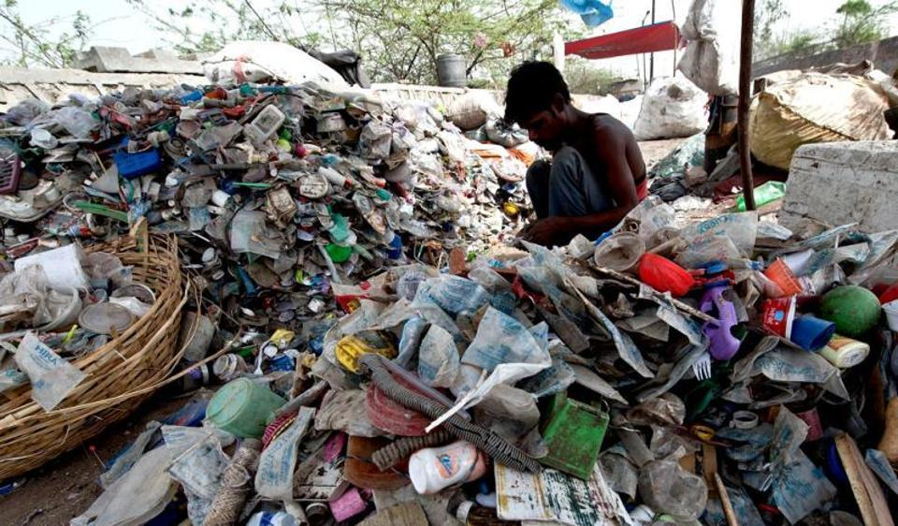

17. BE COOL IN CLIMAGEAR JACKET BY DHAMA INNOVATIONS!

10 Oct '08

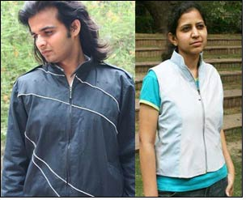

Ahmedabad-based Dhama Apparel Innovations Pvt Ltd, recently developed a unique jacket, named the ClimaGear.  
  
Mr Prasenjit Kundu told [Fibre2fashion](http://www.fibre2fashion.com/), "This is a heating-cooling that works on the principle of 'peltier effect' with the use of 'thermo electrics'. The jacket is run by batteries, and once fully charged it is expected to last for 8 hours."  
  
Mr Kundu is Apparel design student from [NID](http://www.fibre2fashion.com/news/association-news/national-institute-of-design/), working as a designer in this project, alongside Mr Kranthi Kiran Vistakula (Innovator of the Technology), CEO and Founder of Dhama Innovations.  
  
Mr Prasenjit informed, "We are using some Special fabrics at different layer of the jacket and other products. Water repellent and stain proof fabrics are used for the outer layer which is washable. And for inner layer we are using special moisture management and breathable fabrics."  
  
Though he declined to provide specific technical knowledge, Mr Kundu said, "The user can control the temperature as per his or her need. The temperature rage provided in the jacket would be 18 to 30 degrees celsius. Wearer can keep a comfortable temperature inside the jacket while being in any extreme weather conditions."

|  |
| --- |
|  |

## While the makers promise a price tag of Rs 1,500, the Venus portable washing machine is currently available for Rs 2,500 on some online shopping websites.

A portable, bucket mounted washing machine that is available at a fraction of the cost of a traditional one. That was enough reason to doubt the performance of Venus, an innovative product offering by Vimbas Navrachana. Because if it's too good to be true, it's usually is. But seeing the pile of unwashed laundry I finally gave in and decided to place an order.

But how do you order such innovative product? A quick Google search generated a bunch of options. The product is yet to be launched in traditional supply chains (with the [company aiming for a Rs 1,500 price tag](http://ibnlive.in.com/news/venus-this-rs-1500-madeinindia-device-can-turn-a-bucket-into-a-washing-machine-to-go-on-sale-in-april-2015/509689-11.html)). But it is widely available in the parallel ones. I found about four to five websites for this machine as well as multiple seller entries on Olx, Quikr and eBay. Then there was also the official

I contacted few websites but it turned out that most of them were asking me to transfer the amount in an individual account, not one owned by a company. I am usually wary of such transactions. Vimbas is yet to start its distribution but informally they are selling few to friends and acquaintances but at a premium. So I finally placed my order via eBay (it cost me Rs 2,499), at least there was the PaisaPay protection.

I contacted few websites but it turned out that most of them were asking me to transfer the amount in an individual account, not one owned by a company. I am usually wary of such transactions. Vimbas is yet to start its distribution but informally they are selling few to friends and acquaintances but at a premium. So I finally placed my order via eBay (it cost me Rs 2,499), at least there was the PaisaPay protection.

It took about a week for the product to get delivered but the packaging was good. I was not very sold to the idea that it will work properly. I was half expecting it to be a bogus innovation which at the very first try, will make me repent my decision to buy it. Anyway, I tried with some normal daily wear clothes and tested it. The moment of truth was finally there. I was pleasantly shocked at the results. It actually

It took about a week for the product to get delivered but the packaging was good. I was not very sold to the idea that it will work properly. I was half expecting it to be a bogus innovation which at the very first try, will make me repent my decision to buy it. Anyway, I tried with some normal daily wear clothes and tested it. The moment of truth was finally there. I was pleasantly shocked at the results. It actually

worked!

From the first run I understood few things. You need a bigger bucket to run it smoothly (a 25 litre one should suffice). In a smaller bucket there will be restricted space for the machine to work properly. Also you might need to get your hands wet to work on tough stains such as those on the collar and cuffs of a shirt. But for rest of the process, the machine will do well.

But can the Venus washing machine tackle a pair of dirty jeans?

I soaked my dirtiest pair in warm water overnight and the next morning mounted the Venus on the biggest bucket I own. I applied my experience, scrubbed the jeans and put in the bucket. After a washing cycle of five minutes and rinsing it in a bucket of clean water, I found the denim to be cleaner than I have seen in recent memory.

# 18. 89 YO Granny Starts A Website Selling Potli Bags Proving It’s Never Too Late To Follow Your Dreams

The 89-year-old makes beautiful *potli* bags. Taking her passion a step further, the creative woman has now started an online venture to sell them. And here you thought that dreams come with an expiry date!

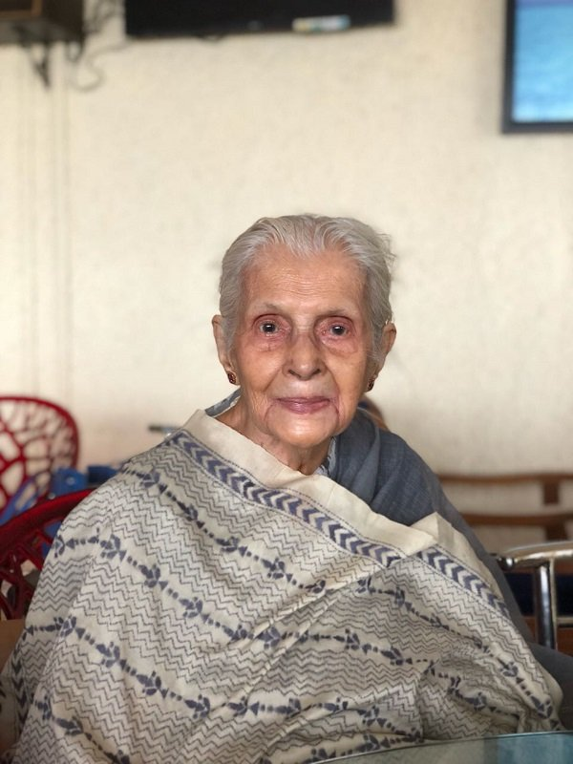

|  |
| --- |
|  |

Born in Dhubri, Assam, Latika Chakravorty's was a meritorious student throughout. After her marriage to an Officer Surveyor in Survey of India, she got to live in different parts of the country due to his transferable job.

## She liked to sew and would stitch clothes for her kids. When the kids grew up, she explored her artistic instincts by making dolls.

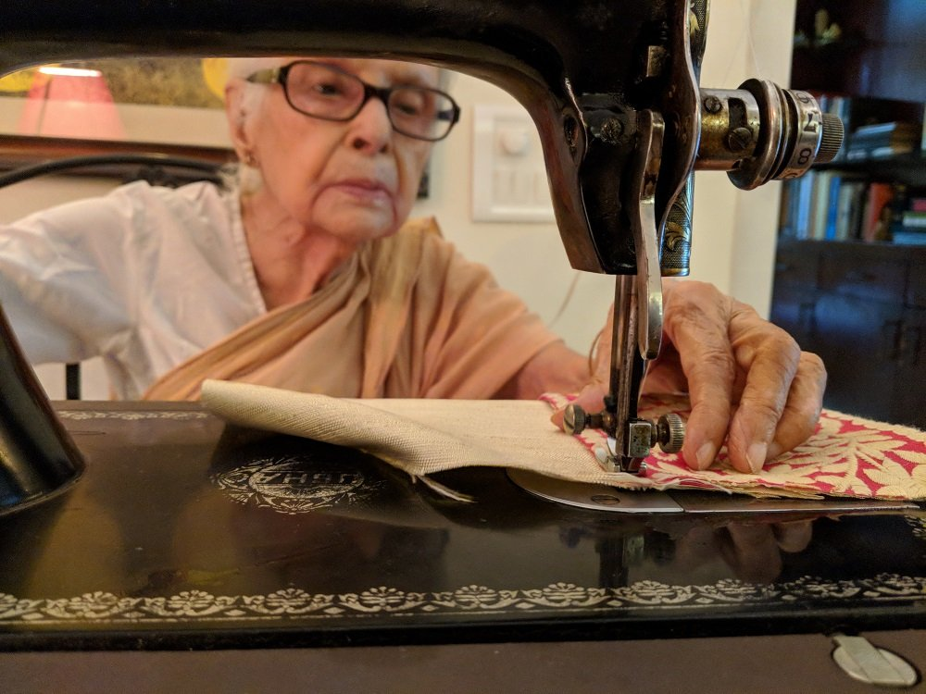

But she began making *potlis*, the cute little bags with a drawstring to open and close it, only about four years ago. She utilises old discarded kurtas and saris to create these bags that make for a lovely accessory for ethnic wear.

## Though she doesn't remember the exact number of bags she has made so far, it's definitely over 300, she says. She's known for gifting these lovely bags to her friends and family.

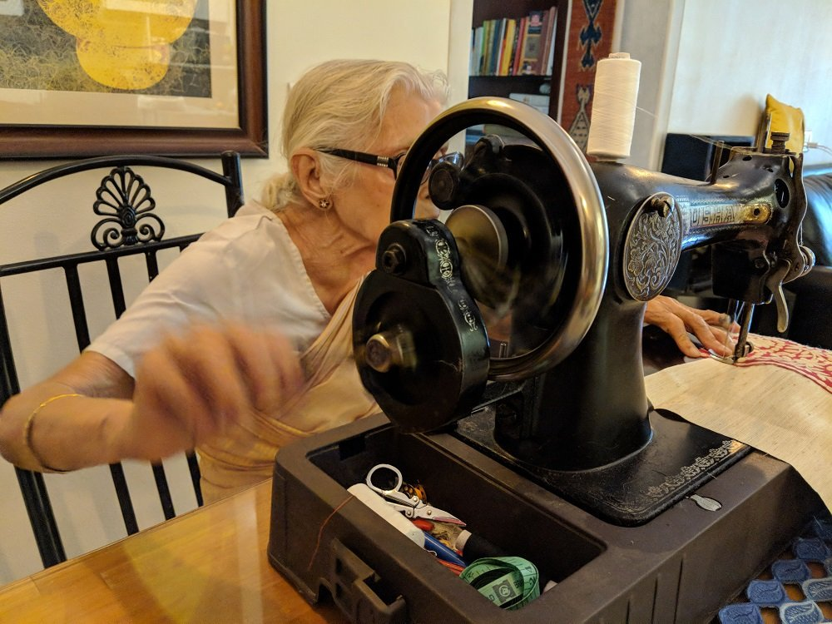

|  |
| --- |
|  |

The online venture came into being when her grandson Joy Chakravorty, who lives in Germany, was visiting his parents and was quite impressed with her grandmother's nifty artwork. He instantly proposed to set up an online venture for her.

## Without wasting any time, Joy created a website called '[Latika's Bags](https://www.scoopwhoop.com/rd?url=https%3A%2F%2Fwww.latikasbags.com%2F" \t "_blank)' and listed the bags on it.

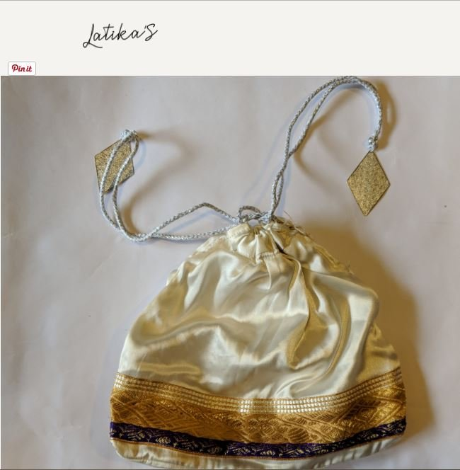Source: [latikasbags](https://www.scoopwhoop.com/rd?url=https%3A%2F%2Fwww.latikasbags.com%2Fshop1%2F002-sari-bag" \t "_blank)

The bags are priced between, ₹500- 1500 and she's been receiving orders from countries like Germany, New Zealand and Oman.

## With this overwhelming response, the octogenarian is unsure if she'd be able to keep up with the demand.

|  |
| --- |
|  |

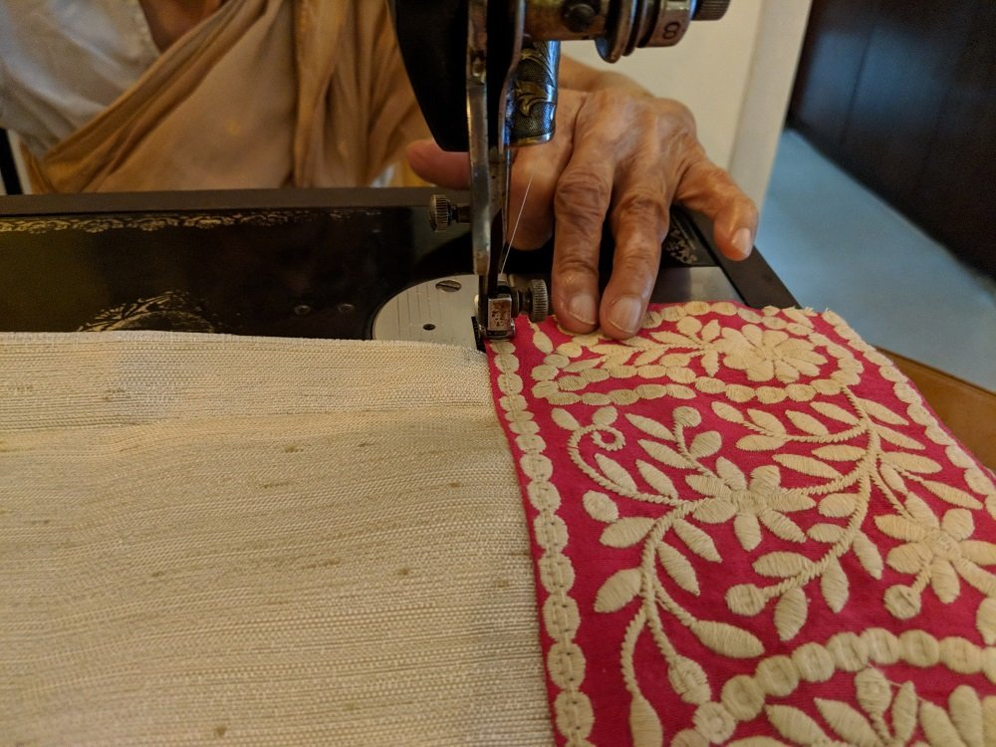

She credits her strictly disciplined life for all the motivation and zeal to work towards her passion. As she told ScoopWhoop:

"I have led a very disciplined life throughout. It keeps me healthy and peaceful. I believe in early to bed and early to rise."

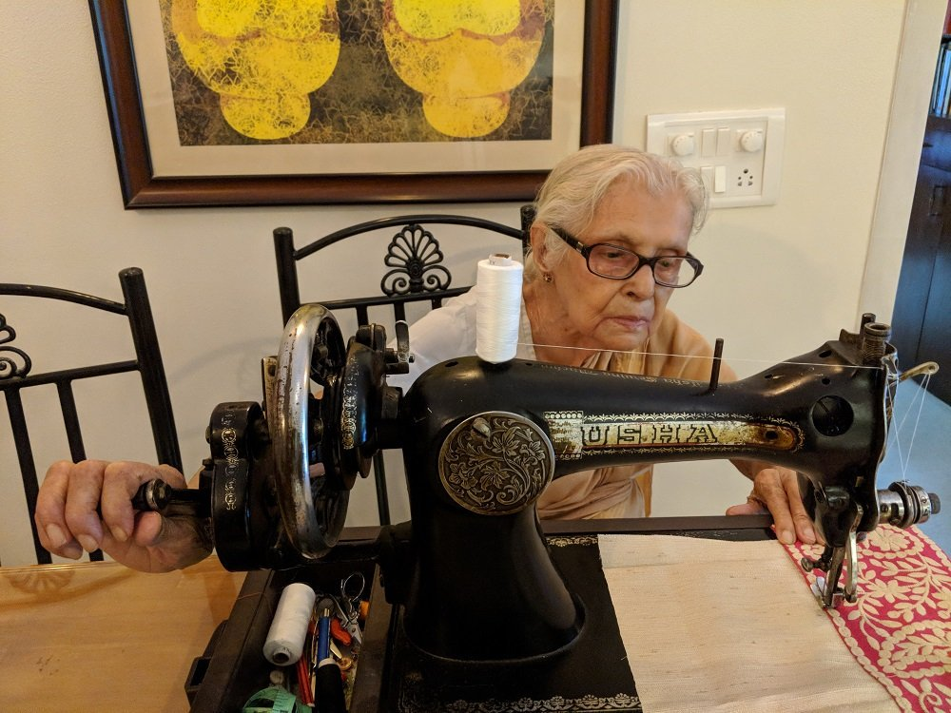

# 19. Hydrogen Powered Three Wheeler

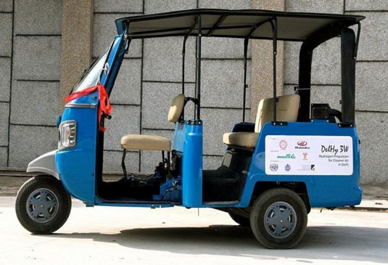

**Description:**

The world's first hydrogen-powered three-wheeler, 'HyAlfa', was launched at the Pragati Maidan on 9th January 2012. United Nations Industrial Development Organization (UNIDO) funded this project to a consortia consisting of IIT Delhi, Mahindra and Air Products (USA). Exhaustive lab tests were carried out on the vehicular engine in the Engines and Unconventional Fuels Lab of Centre for Energy Studies under varying operating conditions. The technical expertise was provided by Prof L.M.Das of Centre for Energy Studies. The test results provided the technical guidelines and thus the existing designs of engines were converted to run on hydrogen. Based on IIT Delhi recommendations, Mahindra had developed hydrogen operated three wheelers for passenger and cargo versions vehicles which were launched at Pragati Maidan during Auto expo 2012, where a hydrogen refueling station has also been set up by Air products. These vehicles are still on road trials in Pragati Maidan after the Auto Expo. Limited field trials in Pragati Maidan show that the hydrogen fueled three wheelers are giving around 85 km per kg of hydrogen consumption.

**Contact details:**

Prof L.M.Das

Centre for Energy Studies

lmdas@ces.iitd.ernet.in

**For more latest research@IIT Delhi:**

# 20. REWRITABLE T-SHIRT

[siddharth](http://www.innovationindia.in/author/siddharth/) | March 19, 2015 | [Featured](http://www.innovationindia.in/category/featured/), [Innovations](http://www.innovationindia.in/category/innovations/) | [No Comments](http://www.innovationindia.in/rewritable-t-shirt/#comments)

Two IIT Bombay graduates, Ayush Jain and Mirik Gogri, conceptualized Humming Whale Product Innovations Pvt Ltd with a vision to successfully create economically viable products that are sustainable for the market from creative and innovative ideas.

One of their fantastic idea is **Rewritable T-shirt,**which**i**s a unique t-shirt on which you can write, erase and rewrite. A wacky idea and immense R&D, and voila! The t-shirt was launched with a tremendous positive response among the youth. Currently, it’s selling in good numbers on bewakoof.com, which is the marketing partner for this product. It also got featured on the TV show Bigg Boss with Salman Khan.

It was a time in their Institute when an attempted change in rules by the elected council and self-appointed opposition leaders standing for the next elections had polarized the student community. Strong debates and cries for impeachment were going around the college.

Enjoying the heat of the moment, some friends around suggested creating ‘I hate ABC’ and ‘I support XYZ’ t-shirts with an idea of making some quick bucks. The idea was duly dismissed with a strong consensus on the fact that people won’t buy them as they stand of no use once this wave dies down.

Hence the idea and the concept of **Rewritable T-shirt** was born.

They tied up with Bewakoof Brands, an e-commerce startup by IITB alumni, which focused on selling humorous and unique apparel products. Our zest for innovation and their experience in t-shirt manufacturing joined forces and major challenges of creating the right material to match the contour of t-shirt while not compromising on the wearer’s comfort were tackled.

After nearly a year of RnD, they finally came up with a sustainable and sellable product and branded it as the rewritable t-shirt.

This guys took a simple idea and turned it into something very unique and mind blowing, truly innovative.

# 21. Sreelakshmi Suresh – A Web Designer and A CEO at the age of 6.

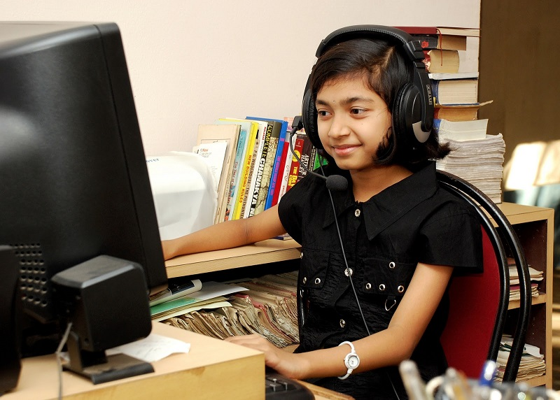

PC: rajeevjohn-theholysecrets.blogspot.in

Age is a just a number says an adage. Achievers can be from all spectrums of age groups – child prodigies, achievers in their teens, middle-aged crew or even senior citizens. All those successful people have proven age doesn’t matter for them as long as their passion and perseverance keep them going. This Kalam Fan Club Post is about a child prodigy who at the age of 6 started designing various types of websites and by the age of 11 started her own company to be listed as one of the youngest CEOs of the globe. This girl **Sreelakshmi Suresh** was not born in an affluent family to be considered as Y-Generation kid with accessibility to all modern gadgets in fingertips. Though she was born in a middle-class family her curiosity to meddle with computers encouraged her parents to give hands-on sessions in computers. At the age of 3 she learned computers, and by the age of 6, she could design her first ever website. She has been recognized with various awards and has started two companies TinyLogo and eDesign at the age of 11 to be identified as one of the youngest CEOs of the globe.

**Early Life**

Sreelakshmi Suresh was born in the year 1998 at Kozhikode (Calicut) in the state of Kerala as the daughter of Mr. Suresh Menon and Mrs. Viju Suresh. Sreelakshmi started meddling with computers at the age of 3 and started designing at the age of 4 and came up with her first website at the age of 6. This girl attends a school called Presentation Higher Secondary School which was inaugurated in the year 2007 and didn’t have a proper website. It was Sreelakshmi who took the initiative to design a web portal to her school and came up with a very good design.

**Youngest Title**

Sreelakshmi’s passion gained her wide recognition across the globe by the year 2006. She was awarded youngest web designer at age of 6 and youngest CEO (for starting companies at age of 11) along with various youngsters like Harli Jordean who is considered as the “World’s Youngest CEO” at age 8 by some sources, and Ajay Puri considered as the “World’s Youngest Web Designer” at age 3. Whether she is the first youngster to achieve the feat is immaterial considering her accomplishments of designing nearly 20 fully functional websites with her companies TinyLogo and eDesign.

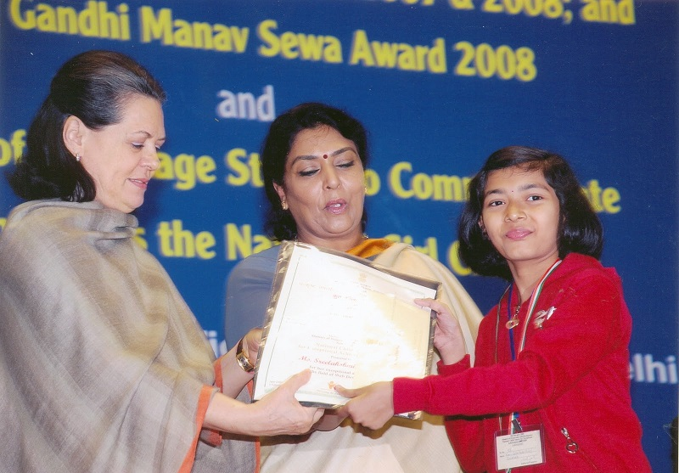

PC: rajeevjohn-theholysecrets.blogspot.in

**Awards & Recognitions**

Sreelakshmi Suresh has received various awards like:

She was honored by the Ministry of Women and Child Development (India), by conferring her

* The National Child Award for Exceptional Achievement in 2008
* The Won the Golden Web Award (U.S.A)
* The Sixty Plus Education Award (Canada),
* The Feeblemind’s Award of Excellence (UK),
* The Webmasters Ink Award (U.S.A.) and Penmarric Bronze Award (Canada).
* The Global Internet Directories Gold Award (USA),
* The WM8C Stamp of Excellence Award (USA),
* The 37th Texa’s Web Award (USA)
* The American Association of Webmasters Merit Award
* The Thomas Sims Greves Award of Excellence (UK)
* The Moms Global Award for inspirational Website 2006-07 (UK)
* The ProFish-N-Sea Charters World Class Website Award (Brazil)
* The Wadeshi Science Movement Excellence Award 2007 (India)

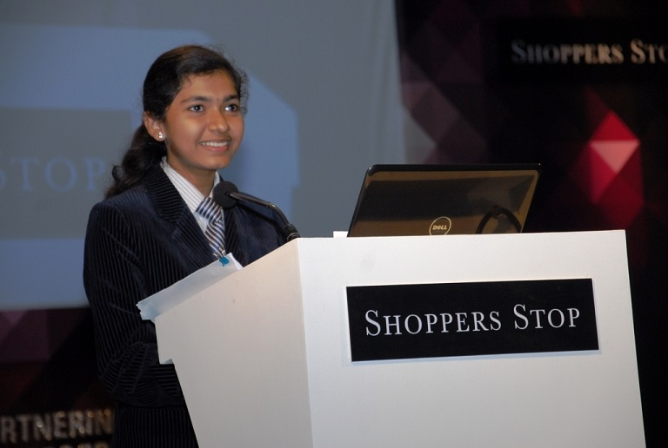

PC: rajeevjohn-theholysecrets.blogspot.in

Her success has been attributed to various factors like Self-Discipline, Perseverance, Planning with Action and dedication. Sreelakshmi Suresh should be the role model for many youngsters to achieve higher heights in their life. Kalam Fan Club wishes her greater success in future endeavors too.

Here is her website: [http://www.sreekutty.com/](http://www.sreekutty.com/" \t "_blank)

# 22. School installs 3D printed sanitary pad dispenser designed by its students

## Girish Nair, the founder of Curiosity Gym, said 3D printing and the new forms of technology needed to be taught to children at an early age so they could adapt and create innovative products.

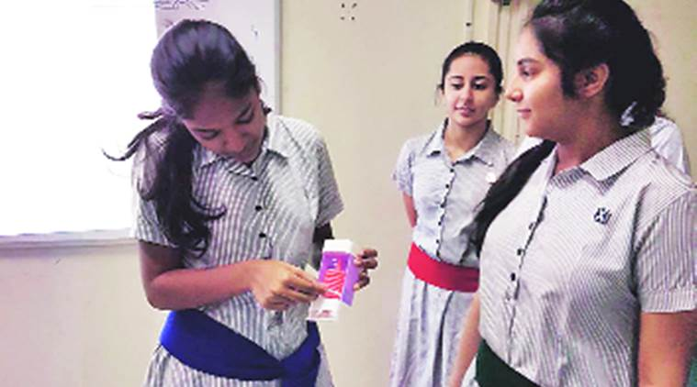

A SANITARY napkin dispensing machine was recently installed at the Cathedral and John Connon School at Fort. Only it is not a regular dispenser installed in government schools or offices. It has been designed by three students and produced using the 3D printing technology. Three girls from the school’s Class XI — Aditi Arya, Malini Dasgupta and Devika Malhotra — built the dispenser as part of their project undertaken in a recently started 3D printing course.

“We were aware that many girls don’t even have access to sanitary napkins and some even stay out of school during periods. Therefore, we decided to design a dispenser that can be built using the 3D printing technology,” said Arya.

While the idea was novel, it wasn’t easy. First they built a cardboard prototype, which they subsequently modified. It was then built into a prototype using plastic. “It’s like a simple vending machine with a coil in a box vertically and pads go in the middle of it. The coil moves once and a pad is released,” explained Arya. To create this, they used a 3D modelling app called 123B. Principal Meera Isaacs was more than impressed with the idea when the girls presented the prototype. The school then decided to install the first one in one of its toilets for girl students.

“No idea is stupid. Only with many such ideas and a lot of brainstorming can we create something so effective,” said Arya, adding that the team learnt that “one has to go through a trial and error process before hitting success”.

The girls are now planning to approach an NGO so that the product can reach and benefit underprivileged girls who can’t afford to buy sanitary napkins. “We have also put in a lot of thought on how to make the dispensers cost effective and easily operable,” said Arya. Principal Isaacs said the course in 3D printing would encourage students to think innovative and be able to create their products. The course is being conducted by Curiosity Gym, an organisation that promotes ‘design thinking’.

Girish Nair, the founder of Curiosity Gym, said 3D printing and the new forms of technology needed to be taught to children at an early age so they could adapt and create innovative products. The organisation began in July 2015 and students have since created objects like fidget spinners, robots, lamps, dog food dispensers and many more that can be operated from a mobile phone.

# 23. Skin Patch to Detect ‘Silent’ Heart Attacks

[May 11, 2018](http://innohealthmagazine.com/research/skin-patch-to-detect-silent-heart-attacks/) [InnoHEALTH Editorial Team](http://innohealthmagazine.com/author/innohealth-editorial-team/" \o "InnoHEALTH Editorial Team)

The death of his grandfather due to heart attack led Manoj Akash, a class 10th student of [Ashok Leyland School](https://thealschool.org/) in Hosur, Karnataka, to invent skin patch which has to be attached to the wrist or the back of the ear and it will release a small ‘positive’ electrical impulse, which will attract the negatively charged protein released by the heart to signal a heart attack. If the quantity of this protein – FABP3 — is high, the person must seek immediate medical attention.

Since class eight he started visiting the library of the Indian Institute of Science in Bengaluru – an hour away from his hometown. He could not afford expensive books and journals. Only option left to visit library for this enterprising adolescent who had an extra knack to comprehend complexities of cardiology just because of his penchant for the heart diseases studies. He was chosen for the [President’s Innovation Scholar’s](https://presidentofindia.nic.in/) In-Residence Programme at Rashtrapati Bhavan.

The 16-year-old says that he investigated a novel concept that could potentially allow patients to detect silent heart attacks by non-invasively sensing the FABP3 biomarker in the bloodstream. ABP3 is a lightweight protein, releases quickly from heart muscle into the bloodstream during a heart attack, and therefore, it is an optimal cardiac diagnostic marker.

According to him, doctors may test a patient’s blood for FABP3. If he or she experiences characteristic symptoms like chest pain. However, not all heart attacks make themselves known through easily noticeable signs. Silent heart attacks, which are becoming increasingly common, are asymptomatic, making them more dangerous than conventional heart attacks.

Patients often “drop dead” while feeling completely normal. This collapse happened to my grandfather on July 3rd, 2015 which served as an impetus for me to find a solution to this problem. In these “silent” cases, doctors are unlikely to administer the crucial FABP3 blood test because there is no visible presentation of symptoms to warrant a diagnostic test. As a result, silent heart attacks go unnoticed.

“I realized that if at-risk patients could test themselves daily for the presence of FABP3 in their blood. They would have higher chances of detecting silent heart attacks as they occur. A method that allows daily self-testing would have to be non-invasive, safe, and easy to use. Ultimately, it would have to involve a transcutaneous blood analysis, which examines the contents of one’s blood without penetrating the skin.

In searching for ways to tackle this challenging prospect. I examined the various distinguishing characteristics of blood proteins that would allow them to be identified transcutaneously. I found that proteins have distinctive masses and electric charges in blood.

So, I used a model to test whether different magnitudes of charged electricity. When applied to a thin area of skin, would isolate FABP3 from the other blood proteins and attract FABP3 to the capillary walls. My results showed that this is true.

This means that the technique that I investigated can potentially be coupled with transcutaneous UV-protein quantification to non-invasively measure the amount of FABP3 in a patient’s blood and alert him or her of a silent heart attack.”

Help Million Hearts Stay Healthy! Is his web page that narrates his vision.

He was frequenting scientific conventions to further his knowledge in the science field. Internet gave him a lot of insight, he admits Clinical trials for the medical device are on. And it could be approved for a human trial. The product would be fit to be launched in the market after two months of human trial, assuming nothing goes wrong.

“I have already filed for a patent and I would tie up with the department of biotechnology for the trial. I would want the Government of India to take the project instead of selling it to a private company because it is for the public good,” he says on his website.

To monitor, regular use small silicon patch stuck to your wrist or back of your ear. Whether there has been a heart attack instead of waiting for a doctor to prescribe a test.

The patch uses a positively charged electrical impulse to draw negatively charged —protein to the surface; If the amount of FABP3 is high, then the person would need immediate medical attention; Experts recommend to use the device twice a day. The product can soon be in the market. It would cost around R 900, cheaper than a glucometer symptoms at all.

Diabetes, high blood pressure, high cholesterol levels all put you at risk of a silent heart attack, experts say. Having a silent heart attack puts people at a greater risk of having another heart attack, which could be fatal. Having another heart attack also increases the risk of complications, such as heart failure.

Chest pain, pain in the left arm or shortness is when of breath characterizes a silent heart attack. A silent heart attack may not show symptoms of chest pain and shortness of breath that doesn’t feel heart attack. Akash aims to study cardiology at the country’s premier [All India Institute of Medical Sciences in Delhi](https://www.aiims.edu/en.html).

# 24. Meet Devaki Jain, A Gandhian Economist Who Has Spent a Lifetime Fighting for Women’s Rights

She’s a renowned writer. An internationally respected economist. The winner of the prestigious Padma Bhushan award. And for decades has been an activist fighting for the rights of women and the poor of India.

And that’s just the tip of the iceberg if one has to describe the astonishingly prolific life and career of Devaki Jain, a development economist, who has long been smashing barriers in India and fighting poverty using Gandhian philosophy.

Born in 1933, in Mysore, Karnataka, Devaki’s father was a civil servant called M. A. Sreenivasan. Her father himself lived an incredible life having been a minister in what was earlier the Princely State of Mysore.

## Education was a main priority in Devaki’s home as she was sent to a slew of convent schools in pre-independent India.

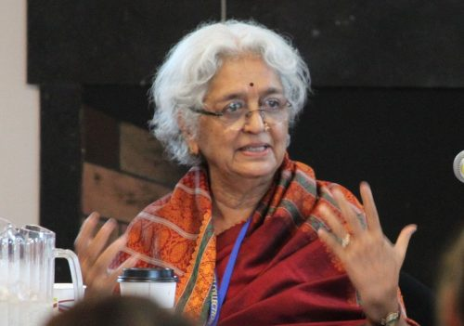

I

A highly intelligent young woman, Devaki, attended Mysore University where she studied Mathematics and Economics and subsequently graduated with three gold medals. At a time when women weren’t even allowed to attend school, Devaki would then go on to attend St. Anne.s College, Oxford University, UK where she studied economics. She became a professor at Delhi University till 1969 where she taught economics.

**Advocacy and women’s rights**

## In 1966, Devaki married Gandhian freedom fighter and writer, Lakshmi Chand Jain.

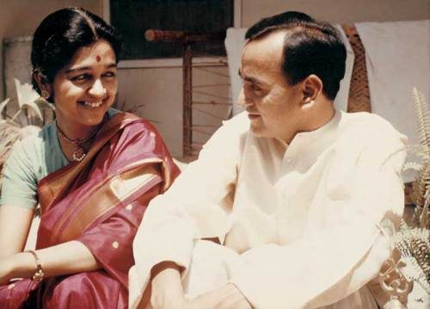

Image [source](https://civildisobediencenow.wordpress.com/2011/06/26/gallery/)

And it was also around this period that her lifelong tryst fighting for women’s rights began. As she herself [notes](http://www.cherwell.org/2014/05/26/interview-devaki-jain/), she was unaware of feminism or women’s rights movement. It was only after a publisher approached her to write or edit a book about the status of women in India did she realise the deep chasm that divided men and women in the country. And she became involved in women’s rights.

Her friendship with feminist Gloria Steinem, whom she met in America also played a crucial role in how Devaki came to view women’s rights. During one of their conversations, Steinem spoke to her about the importance of women working together to empower themselves and this left an indelible mark on Devaki who came to identify herself as a feminist even she was met with derision in India for the very fact

Between 1973 and 1975, she edited and published Indian Women, for the Government of India, Publication Division and it also when she began putting together resources to found the Institute of Social Studies Trust in Delhi. The body has since conducted in-depth research on Indian women, especially ones stricken by poverty.  She also went on to start the Indian Association of Women’s Studies (IAWS), Development Alternatives for Women for a new Era (DAWN), and Kali, Feminist Publishing House.

She also played a huge role in helping organisations like SEWA Ahmedabad to spread their message to larger platforms across the country.

## ****Fighting for women’s rights became a matter of crunching numbers****

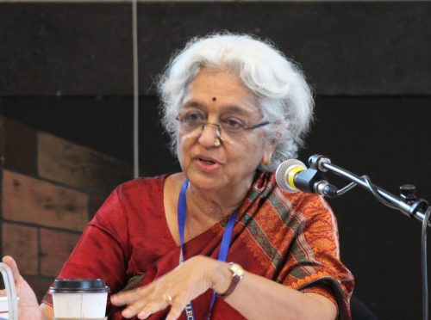

In a freewheeling interview with *[Cherwell](http://www.cherwell.org/2014/05/26/interview-devaki-jain/" \t "_blank)*, Devaki spoke about how she used economics to further her fight for women’s rights in the country. She says that she noticed, “in statistics, you define a worker as main, subsidiary, supplementary etc. Women are usually categorised as a supplementary. But I was able to argue nationally that amongst the poor, women are the main breadwinners as they are willing to do anything; sweeping, cleaning, selling scraps, anything to put food on the table. Then I realised that I had to visualise what women are as economic agents.”

**Understanding rural India**

Through the course of her life, a staunch Gandhian herself, she has used Mahatma Gandhi as her guiding light when it comes to dealing with economics. She advocated democratic decentralisation and approached her work with a strong sense of Gandhian morals.

She has worked with the Government of India in various capacities and was instrumental in designing credit programmes for rural women, was a member of a number of policy task forces for the country and was part of the core committee.

Her work has indelibly helped women across the country and by working with the government she has helped improve the conditions of millions of women in the country.

**Fighting alongside the UN**

Any profile of Devaki Jain would be incomplete without mentioning the extensive work she did internationally for the emancipation of the women and poor through her association with the UN. In fact, she even wrote a book, Women, Development, and the UN: A Sixty-Year Quest for Equality and Justice, highlighting how the fight for women’s rights has come along over the years.

She was the Chair of the Advisory Committee on Gender for the United Nations Centre in Asia-Pacific. And from 1987 to 1990, she was a member of the erstwhile South Commission headed by Dr. Julius Nyerere. Along with 26 other hand-picked economists, she helped develop an action agenda for South-South economic co-operation.

## For all the work she had done in perpetuating gender equality, she was conferred with Bradford Morse Memorial Award by the UN. She happens to be only one of two women to ever get this award.

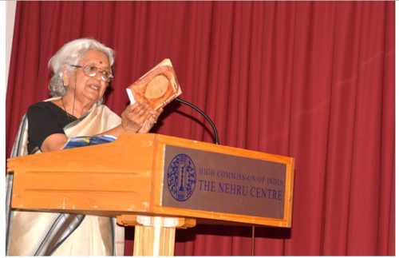

Photo [source](http://www.nehrucentre.org.uk/gallery/highlights-of-2013.html)

And her fight against injustice is still not over. Currently living in Bengaluru, she is as active as ever for advocating for the rights of women and the poor and continues to have her voice heard through in-depth columns in newspapers and by directly engaging with women through various panels.

# 25. Arunachal teen designs goggles to help the blind detect obstacles

[Think Change India](https://yourstory.com/author/think-change)     posted on 24th March 2017

Anang Tadar is an 11th-standard student from Arunachal Pradesh who has designed special goggles to make life easier for the visually impaired. He studies at New Galaxy Academy, Nirjuli, and has named his invention Goggle For Blind (G4B). These innovative goggles make use of ultrasound and infrared sensors to detect obstacles in their way.

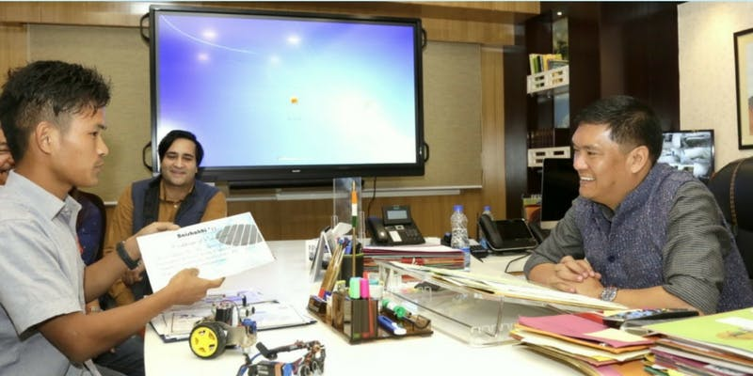Image Source: [North East Live](http://northeastlive.in/2017/03/cm-pema-khandu-offers-full-financial-support-to-anang-tadar-to-develop-g4b/)

These goggles use the principle of echolocation that bats use at night, and can help detect any obstacle within a range of 2 metres. Echolocation is the process by which sound waves echoes are used to determine whether there is any object present in the vicinity. Two ultrasound sensors are present on both the left and right side of the goggles to detect any obstacle. According to the [*Hindu*](http://www.thehindu.com/news/national/other-states/arunachal-teen-develops-goggles-to-help-the-blind/article17521691.ece), Anang also said,

**There is also an infrared sensor in the middle of the gadget to detect obstacles in case both the ultrasound sensors fail.**

On detecting the obstacle, the goggles produce a beep along with vibrations to alert the person. This will help a blind person detect nearby objects without using a stick.According to [*Hindustan Times*](http://www.hindustantimes.com/india-news/arunachal-boy-develops-goggles-for-blind-using-parking-sensor-technology/story-79mSB7lxMUuYfSM9NwswxJ.html), Anang told journalists in Itanagar,

**These days there are so many obstructions both inside the house and outside. The G4B will help blind people move around a lot easier.**

Anang was recently given the Dinanath Pandey Smart Idea Innovation Award for inventing the G4B. He also participated in the national-level science exhibition organised by the National Innovation Foundation (NIF) at Rashtrapati Bhawan in New Delhi. According to the Arunachal Pradesh government, UNICEF was impressed with the invention and has requested Anang to build more prototypes. The aim is to make it comparatively lighter as it's a little bulky presently. As he does not belong to a very wealthy family, he approached Chief Minister Pema Khandu for his help and has been assured full financial support.

The vision and innovation this young boy has displayed are commendable definitely worthy of applause.

# 26. This student duo from IIT invent a safe, cheap way for women to use public restrooms

[Think Change India](https://yourstory.com/author/think-change)     posted on 26th September 2018

Sanitation has always been a prime concern in India. According to a [report](https://thewire.in/health/732-million-india-tops-list-number-people-without-access-toilets-report) by WaterAid, 732 million people in India do not have access to basic sanitation. In urban India despite having public toilets facility, a whopping [71 percent](https://sanfe.in/novel-innovation-by-iit-delhi-alumni-and-professors-working-on-health-care-and-sanitation-for-women/) of the public washrooms are unusable.

The worst affected, as one can imagine, are the women, especially those who travel a lot. To get a clearer picture,[check out these statistics:](https://sanfe.in/)62 percent of pregnant women find it painful to urinate in a semi-squat position, 50 percent suffer from UTIs (urinary tract infections) and 48 percent hold their urine to avoid using public restrooms.

To mitigate UTIs arising out of using public washrooms, Sanfe (Sanitation for Female) has come up with a product, that allows women to use the loo without sitting on it. Sanfe is a startup that was founded by Archit Agarwal and Harry Sherawat, both third-year textile engineering students at IIT-Delhi.

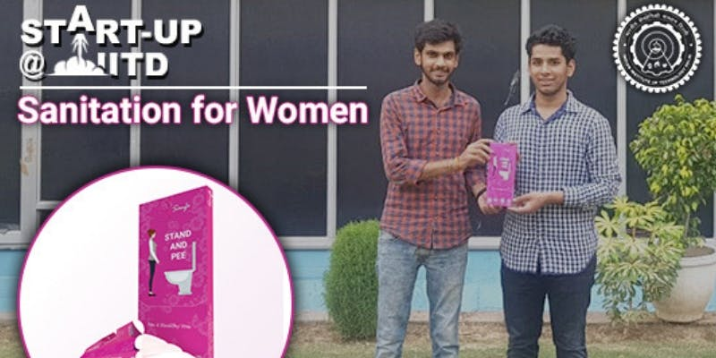Harry Sehrawat (left) and Archit Agarwal. Source: [IIT-Delhi](http://www.iitd.ac.in/content/startupiitd-sanitation-women)

**The equipment costs only Rs 10 and is available at all pharmacies in AIIMS, Apollo Hospital.** The duo has also filed a patent for their equipment, which they claim is biodegradable and easy to dispose of.

It all began when Archit was working on a project in his first year, compiling a report on the [plight of public washrooms in Delhi](http://www.iitd.ac.in/content/startupiitd-sanitation-women).

Through his project, he realised the issues a woman has to face due to unhygienic toilet seats. His project's finding was supported by WHO and stated that one in every two women suffers from urinary tract infection at least once in their lifetime.

Archit later collaborated with friend Harry, who was working on an automatic toilet cleaning machine. They both then started Sanfe.

In an interview with [DNA](https://www.dnaindia.com/delhi/report-iit-delhi-students-invent-design-friendly-pee-device-2667495)India, Harry said,

**We visited many public loos across the city and almost all of them were unhygienic and unfit for use. Upon further research, we also found out that public toilets were also one of the prominent reasons behind UTI in women.**

Archit [said](http://www.iitd.ac.in/content/startupiitd-sanitation-women),

**While doing the surveys I realised the problems women, especially the pregnant women, faced. This was when I thought of making a product which allows women to stand and urinate. There had to be some methodology to avoid contact with the toilet seats in public washrooms. We started with a simple funnel design and gave it to some women for trials.**

The design of the product remained an issue as neither knew what could be used by all women. To address the dilemma they approached Prof Srinivasan Venkatraman at the Dept of Design, IIT-Delhi.

Harish [said](https://www.dnaindia.com/delhi/report-iit-delhi-students-invent-design-friendly-pee-device-2667495),

**It is compact enough to be carried in a purse and can be disposed of easily after one use. Among various other advantages, the surface area of the apparatus has smooth curves to avoid paper cuts.**

As the product was ready, the duo asked their friends and others to use and give them feedback on which the design in the future will be altered. The duo are now getting orders and looking at getting their product out beyond Delhi.

[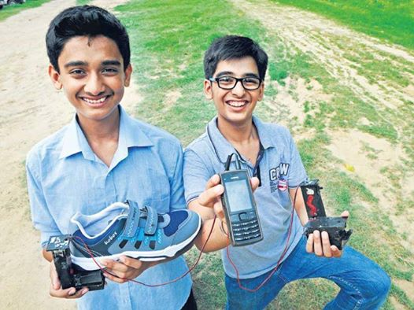](http://www.faadooengineers.com/attachment.php?attachmentid=40007&d=1408604791)  
  
  
**27. Walkie Mobi Charger**  
Two students named Anand Gangadharan and Mohak Bhalla who are studying at Delhi�s Mount Carmel school, have invented a compact attachment, called Walkie Mobi Charger which, when attached to the heel of the shoe, will automatically act as a portable mobile charger.   
  
The gadget generates electricity up to six volts, as against five volts released through a plug point and ensures that the phone battery is charged at a faster pace. So if a plug-in charger takes half-an-hour to charge a phones up to 25%, the walking device will charge 40% of the battery in the same time.  
  
  
The device functions on the principle of electromagnetic induction. The compression and relaxation caused by walking creates pressure on the sponge attached in the middle which produces electricity.Two LEDs, blue and red, indicate the supply of electricity and battery charging, respectively.

# 28. This 15-Year-Old Is India’s Youngest Drone Builder & He is Saving Lives Already!

## What’s truly exciting is the global recognition his technology is garnering. The South Korean army has shown a keen interest in acquiring this technology and Harshwardhan says, “my aim is to save lives – to me it doesn’t matter whether the person is in India or Korea.”

Harshwardhan Zala is 15 years old – an age when kids are busy at school, preparing for examinations and thinking, perhaps, about what they would do in the future. But Harshwardhan already has a handful of patents to his credit and has earned the title of being India’s Drone Wiz. He also happens to be the founder and CEO of his company, Aerobotics7 Tech Solutions.

At 14, Harshwardhan designed a smart solution through which drones could not only detect but also defuse landmines in war fields, saving many lives in the process. His vision, he says, is to clear all the landmines around the world, thus making it a safer place. “Do you know there are more than 100 million active landmines across the globe?” he asks me as we begin our conversation.

“My goal is to create technological solutions to save thousands of lives across the world, and this is just the beginning,” says Harshwardhan in this amazing video about his work.

To know more about his phenomenal journey, The Better India caught up with Harshwardhan. For a young achiever, Harshwardhan is a stellar example of humility. He is soft-spoken and eager to explain his work to me, without once sounding arrogant.

## Starting young

A resident of Ahmedabad, Harshwardhan is the only son of an accountant father and homemaker mother. Speaking about his first innovation, he says, “I was 10 when I made a remote-control which could be used to control and operate home appliances wirelessly. At the time when I made this, there were no such gadgets available in the market.”

After having made the device, Harshwardhan’s parents also recognised his talent and encouraged him to take it further. “My parents have certainly been supportive of me; emotionally, physically, and of course financially. They have always stood by me,” he says.

While regular ten-year-olds are about stealing a few extra minutes of television or getting one more chocolate out of their mother, Harshwardhan was thinking about what he could build next.

## Technology when used well

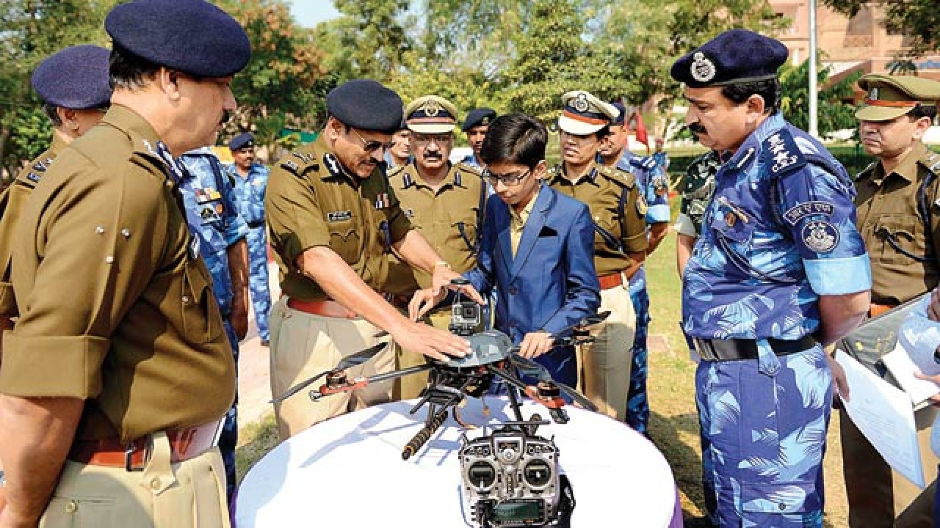Harshwardhan’s Interaction with Director General of CRPF

“I would be reading books about the problems that the world was facing, and when I could, I would visit the cyber café and watch YouTube videos about these problems. Finding a solution was like my mission then,” he says.

Since Harshwardhan did not have access to the Internet at home, he would go to a nearby cyber cafe and spend hours there. His partner in this was his grandfather who would always accompany him since Harshwardhan was not allowed into the café without an adult.

“The first time I visited the cyber café I was turned away because I was not 18-years-of-age. That was when my grandfather decided to come along. I would spend about seven to eight hours each session, and he (grandfather) would sit with me, patiently,” he says.

At 72, Harshwardhan’s grandfather, Dilavar Singh, is also equally invested in his success.

Harshwardhan draws his inspiration from former President of India APJ Abdul Kalam and Steve Jobs. “I have never liked going out much or watching cartoons and movies. I enjoy watching documentaries and feel that there is always so much to learn from them,” he shares.

In their endeavour to nurture innovation in India, Marico Innovation Foundation is helping Harshwardhan raise funds to better his technology through a crowdfunding campaign. You too can be a part of his innovation journey by supporting him.

Top of Form



Bottom of Form

Unable to view the above button? *[Click here](https://www.ketto.org/fundraiser/aerobotics7)*

## Ignoring the noise – focusing on the goal

While Harshwardhan is working, he is like a horse with blinkers. He chooses to only look at the end goal and doesn’t waiver from that path. He speaks about how there were times when his friends would make fun of him because he would refuse to play with them. “I have been called a ‘home-person’ who just prefers to stay indoors, but then I never bothered about anything that was said about me,” he says.

## The video that changed everything

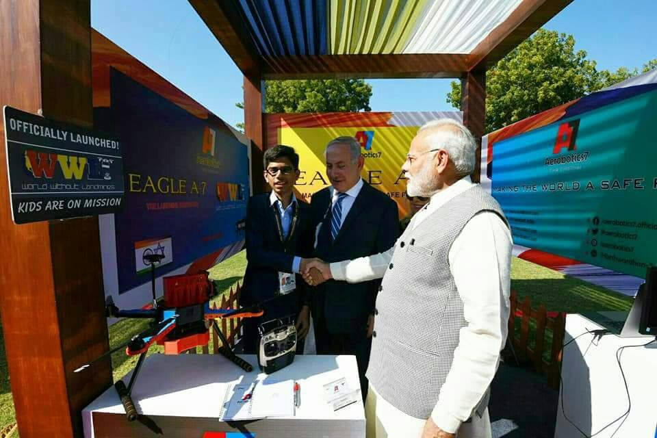\

One such day at the cyber café, Harshwardhan saw a demonstrative video, which reflected how people die due to explosions in undetected land mines.

“This got me thinking about active landmines. I found that for over 60 years, researchers have been trying to find a solution to this problem and still hadn’t,” he recollects. He adds, “I worked on a prototype and went to different companies to tell them about my solution. Unfortunately, none of them took me seriously. Some advised me to complete my education, while others were outright dismissive.”

Harshwardhan went to two-dozen companies with his idea, but after being rejected by all of them, he founded his own company with the money that his parents put together.

## Harshwardhan’s drone

Two years of intensive work later, Harshwardhan’s drone was ready to be unveiled. The drone goes into the field, surveys the ground, and sends real-time signals to the nearest army base. The drone also drops a package on the location to mark it. The drone is also fitted with a wireless detonator, which can be activated without risk to any human life.

“I am currently working with the Indian Army and CRPF to help clear all the landmines in the country. Once that is accomplished, I will share my technology with the rest of the world,” he says.

What’s truly exciting is the global recognition his technology is garnering. The South Korean army has shown a keen interest in acquiring this technology and Harshwardhan says, “my aim is to save lives – to me it doesn’t matter whether the person is in India or Korea.”

## Tryst with Marico Innovation Foundation

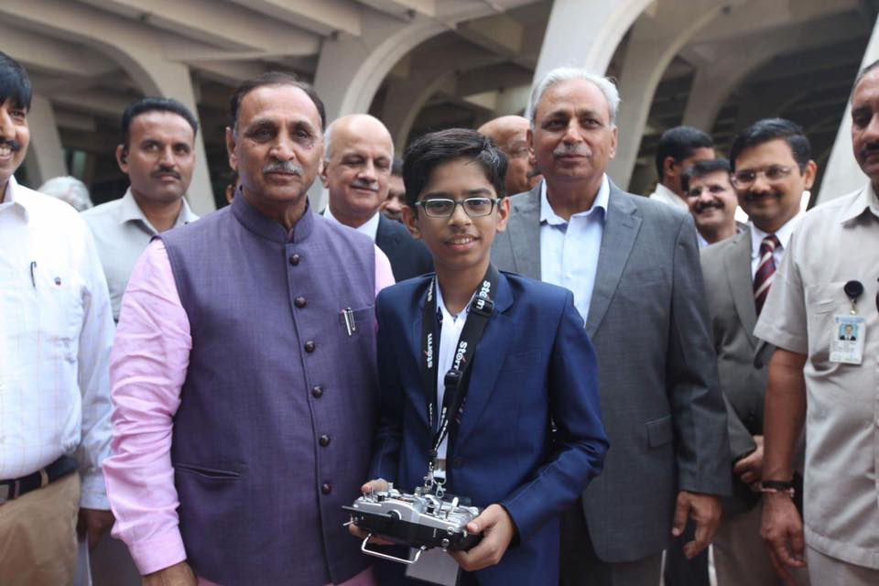Harshwardhan meets Shri Vijay Rupani

Established in 2003 by Harsh Mariwala, Marico Innovation Foundation strives to nurture innovations that add to India’s growth story. Through MIF Awards, the foundation has identified and showcased more than 57 breakthrough innovations in our country. Harshwardhan was invited to be a part of the Fire Side Chat with Young Innovators at the 2018 edition of MIF Awards.

Being a part of the event was of great significance for Harshwardhan. “I was in the same room as so many CEOs, Directors, and innovators – it was truly an enriching experience for me. Being able to share my story with such an elite audience was a thrill for me. I was also very nervous,” he adds for good measure.

“I was approached by so many people at the event who wanted to know more about my work and invited me to their office. Meeting Harsh Mariwala sir was also a high point; his appreciation of my work will always be special,” he says.

Priya Kapadia, Head of MIF, says, “The sheer volume of learning for us, seeing these young innovators has been incredible. One of the biggest takeaways for us, as a foundation, has been that innovation and the zeal to be an entrepreneur can strike at any age. It is that curious mind that we aim to nurture and engage with.”

The team spent a significant amount of time with the young innovator and his family to understand his journey and was proud to showcase the spirit of innovation in him.

## Life after becoming ‘famous’

“Nothing has changed. I still do all that I did before,” he reveals. “My mother still finds reasons to pull me up and scold me,” he says with a light laugh.

“The one thing that has changed is that I now sleep much later and visit various offices through the week.”

When asked if he finds time for his favourite outing and foods, he says, “We do go out, and I especially love the Gujarati street food in Ahmedabad. Khaman dhokla is my favourite.”

Harshwardhan is working towards providing for a safer tomorrow- for us and for those who keep us safe. While he has the intelligence to make that happen, he needs our support to help him build these innovations.

We invite you to come forward in support of the young innovator and help him achieve greater success.

# 29. Son of an electrician, Jamia student bags Rs 70 lakh package from US firm

Son of an electrician,**Mohammed Aamir Ali,** a diploma student from Jamia Millia Islamia (JMI) Delhi, has walked out with an annual package of $100,008 (approximately ₹70 lakh) from **Frission Motor Werks**, an American firm. The firm has assigned him the post of battery management system engineer at Charlotte in North Carolina. JMI said this is the highest salary package for any Diploma in Engineering student at the college since its inception.

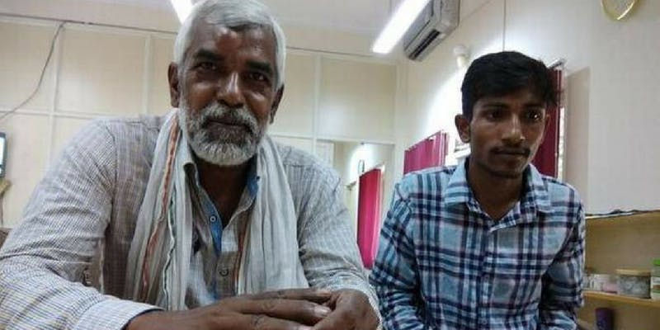Source: [The Hindu](https://www.thehindu.com/news/cities/Delhi/jamia-student-makes-history-bags-70-lakh-per-annum-job-in-us/article24748205.ece)

Mohammed could not get admission for an engineering course despite performing well in the JMI school board examination. After failing in his first attempt to get into the engineering course, he opted for a diploma in Mechanical Engineering at JMI in 2015.

Despite his failures, his passion for science and technology led him to work on electric vehicles. Mohammed says that if his project succeeds, then the cost of charging an electric vehicle in India will become nearly zero, as per [The Hindu](https://www.thehindu.com/news/cities/Delhi/jamia-student-makes-history-bags-70-lakh-per-annum-job-in-us/article24748205.ece).

Speaking more about the project Mohammed said,

**Initially, my teachers didn’t believe me as it was a new area of work. However, assistant professor Waqar Alam finally realised the potential and guided me.**

In one of the college fairs, he made a prototype of his research and submitted. Impressed by Mohammed’s idea, Professor Waqar Alam uploaded it in the university’s official website, which is when Frisson Motor Werks, an American company based in Charlotte in North Carolina, reached out to the college administration.

His father Shamshad Ali shared his feelings after his son got the job offer and said,

**Aamir would ask questions on the functioning of electrical equipment and electricity that even I could not answer despite being an electrician. I always told him to work hard. I am very happy for him today.**

# 30. TBI Blogs: An Auto Driver’s 19-YO Son Built a Buggy Car From Scratch Using Video Tutorials From the Internet

Nineteen year old Prem Thakur has no background in engineering. But that didn’t stop him from pursuing his dream of building his own buggy car.

Prem Thakur zooms across Navi Mumbai’s suburban streets in a swanky looking buggy car. As he pulls into the petrol pump, all the attendants pull out their mobile phones to take pictures of the car. Prem, the 19-year-old creator of the car, beams like a proud father. “I have built this buggy from scratch, using an old sedan’s engine,” he tells [Amol Lalzare](http://www.videovolunteers.org/author/amol/), the correspondent from [Video Volunteers](http://www.videovolunteers.org/) who first reported this story.

With limited monetary resources and no background knowledge of engineering, Prem, a commerce student, learnt how to make the buggy car with the help of tutorials from YouTube. Taking lessons from the Youtube Do-It-Yourself (DIY) videos, Prem has put together the entire car from scratch.

## “In four months time, I wielded the car from the chassis up and painted it all by myself,” he proudly tells us. The buggy even has a few fancy features, including cool side-blinkers and a music system with USB port.

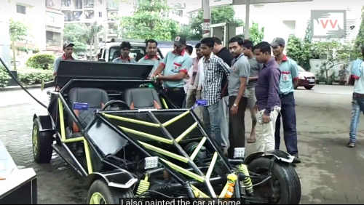The car draws many admirers wherever it goes

Prem’s story is unique because of his family’s support in his ambition.

A resident of Kharghar, a suburb in the planned township of Navi Mumbai, Prem comes from a humble background. Even though his father, a rickshaw driver, earns a meagre daily income of Rs. 500-600 ($ 7 – $9), his father was determined to ensure Prem’s education.

“My father got me a computer when I was 12. Since then, I have used the internet to learn all sorts of things, including how to make a buggy car,” says Prem.

A car enthusiast since childhood, when Prem expressed his desire to make a car by himself, his parents could have easily cited monetary difficulties. But instead, the family and his grandmother came together and helped him realise his dream. Putting the buggy together cost the Thakurs almost Rs. 2.5 lakh ($ 3800 approximately).

## “Had it not been for my family and the internet, I couldn’t possibly have built this car,” Prem says.

Prem Thakur

While the family has spent a significant amount of their household earnings, on Prem’s dream, the machine’s roar and speed prove that their investment in his dreams is not futile.

# 31. Printing Low-Cost Glucose Test Strips on Paper

Imagine just being able to fire up an inkjet printer and print out perfectly usable glucose test strips. Ah, the money that could be saved, among other things!

It may seem off-the-wall strange, but a startup company that began almost three years ago as a Clemson University student research project in South Carolina, [Accessible Diagnostics](http://upstatebusinessjournal.com/news/glucosense-researchers-launch-accessible-diagnostics-company/), is developing what it calls GlucoSense, a new type of test strip made out of commonly-available materials that costs just pennies to make in comparison to what’s out there now.

We also happened to hear of a Bangalore company developing silk-weaved strips featured in a recent [NPR story](http://www.npr.org/blogs/goatsandsoda/2015/01/08/375442225/weavers-turn-silk-into-diabetes-test-strips), with hopes of rolling out their offering by year’s end.

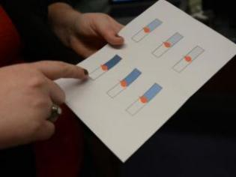GlucoSense paper strips

These efforts come at a time when both health care costs and the rates of diabetes are skyrocketing in the U.S. and around the world — meaning more people than ever need glucose strips, while fewer have affordable access these essential diabetes supplies.

Since GlucoSense is led by in large part by a young type 1, just finishing grad school, we couldn’t wait to find out more.

## 32. A Solution for Tanzania

The Chief Technology Officer is 24-year-old Kayla Gainey, fellow type 1 who was diagnosed at age 2. Kayla got involved at Clemson when she went to speak to her professor, Dr. Delphine Dean, about graduate school and a possible summer internship. She heard about the research project aimed at helping those with diabetes in the East African country Tanzania, where diabetes supplies are far from accessible. Dean had met with the country’s leader, who told her about the huge diabetes problem there and how even donated supplies don’t help much because the meters and strips are often mismatched, and cannot be used together.

So, Dean came back with this idea and soon enough had roughly a dozen students involved, including Kayla. GlucoSense was born.

Here’s a video the team made explaining these issues, and describing how their new low-cost meter and printable strips work:

“I’ve always been a tinkerer and found any excuse to get my hands on a tool,” Kayla says, noting that is what put her on the path of studying bio-engineering with the goal of eventually going into insulin pump design. That all fit right into her own D-world, as she’s been insulin pumping since her childhood and also uses a CGM. “I’m not saying I can do it better than anyone. Just that I understand the patient perspective, and that could be an asset.”

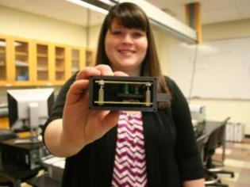Kayla Gainey GlucoSens

When she started on the GlucoSense project in summer 2012 as one of about a dozen students, Kayla says she started to feel her focus switch in the diabetes device design universe, and she was hooked. Now, nearly three years later, this has become her graduate school project and she’s officially the CTO for Accessible Diagnostics, serving with co-founders that include her Clemson professor and also a local South Carolina businessman and investor.

“This whole startup process has been a happy mistake,” she says. “We weren’t planning for that to happen when this research project began; we were just trying to make a successful meter and strip that could help people in Tanzania.”

The meter isn’t complicated, Kayla says. It’s similar to the old bulky LifeScan OneTouch 2 meter that debuted in the early 90s. The idea is that it’s made from the commercially-available equipment that they have in Tanzania so they can make these themselves, at low cost.

Here’s a look at an early prototype of the meter:

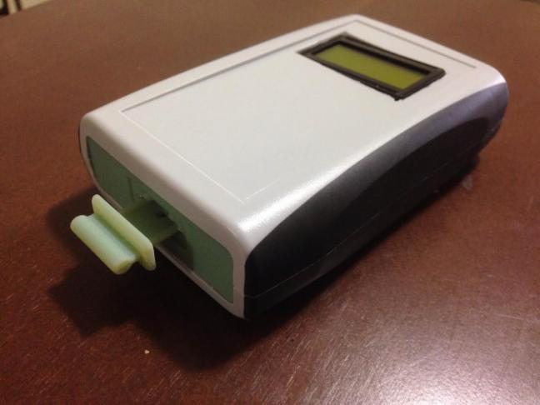

“It’s a rectangular box and not a very tiny meter, but it’s partially because we’re working with 9-Volt batteries. Those are solar-rechargeable there, and that’s important because many homes don’t have power,” Kayla says. “But that adds bulk to it. We went back to the older tech because it’s less expensive.”

As for printing the strips from an inkjet printer: Instead of shooting out ink onto the paper, it spits out enzymes that coat the piece of paper to create these glucose strips. And the cost? Roughly 5 cents per strip, compared to the big-brands that run as much as $1 or more each.

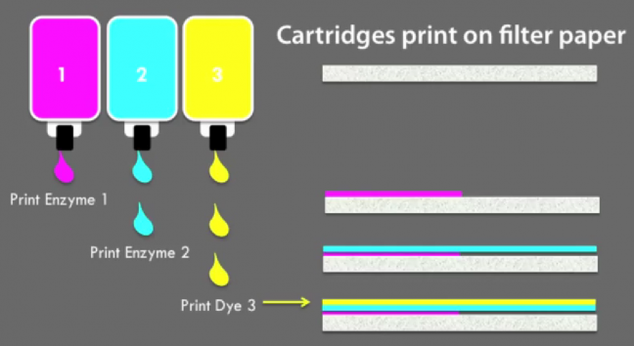

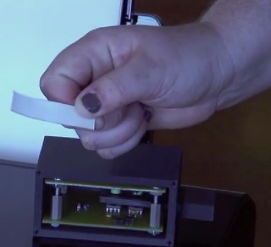

## Testing Goes Retro

Since the internal components of the strips are different, you also use them slightly differently, Kayla tells us. Normally, you insert a strip into the meter and then apply blood on the edge, and it sucks that droplet into the strip for processing a result. But with GlucoSense, you apply the blood drop in the center of the paper strip first, and then place the paper strip into a cartridge that slides into the meter for reading results.

Actually, Kayla tells us that a big foundation of this technology is the “retro” component; it goes back to the 80s or 90s standard, when blood drops were bigger, the test time was longer, and the meters seemed super-sized compared to our 21st century devices. And Kayla claims that  GlucoSense is actually more accurate simply because those factors allow for it. Modern meters have more complicated processes going on inside, packed into smaller packages, so the meters aren’t always as accurate as the ones we had a couple of decades ago.

“With this older tech, there is less room for human error compared to what we have now,” she said.

## First World Access?

Kayla says the business is talking with the International Diabetes Federation’s [Life for a Child program](http://www.idf.org/lifeforachild), exploring a partnership that could get this meter to various places around the global beyond Tanzania, once their prototype is finalized and funding and approvals are in place.

Meanwhile, it’s unclear how and when GlucoSense could make its low-cost testing system available in the U.S. The Accessible Diagnostics team is hiring an FDA consultant to start regulatory conversations, we’re told, and hopefully in the next year they will know more about how regulators are thinking about this “retro” approach to glucose testing.

Volume is one big issue, since one set of GlucoSense inkjet cartridges makes 4,000 strips, which is fine for distribution in a clinical setting (as is practice in the Third World). But for an at-home kit, it wouldn’t be ideal since the strips would expire more quickly than an individual PWD would be able to use them.

Automating production could change that, but much depends on FDA reactions, Kayla says. Of course, they would someday like to see this become an open-source, do-it-yourself system for PWDs everywhere, if possible.

They are hoping to clarify regulatory issues in the next year and have at least some version of their low-cost testing product to sell here in 2016.

“I am very proud of all this, and hope we can also use this to encourage people with diabetes — especially the younger ones,” Kayla says. “I’d encourage diabetics to use their diabetes to help others, to see it as a positive. You don’t have to go out and invent a glucometer or strip. Just go out and be an advocate, help people be aware of diabetes no matter where you live.”

# 33. These 'Eco-Friendly' Bricks Are Made From Garbage

## A single 'eco-friendly' brick weighs 17 kilogram and costs Rs. 35.

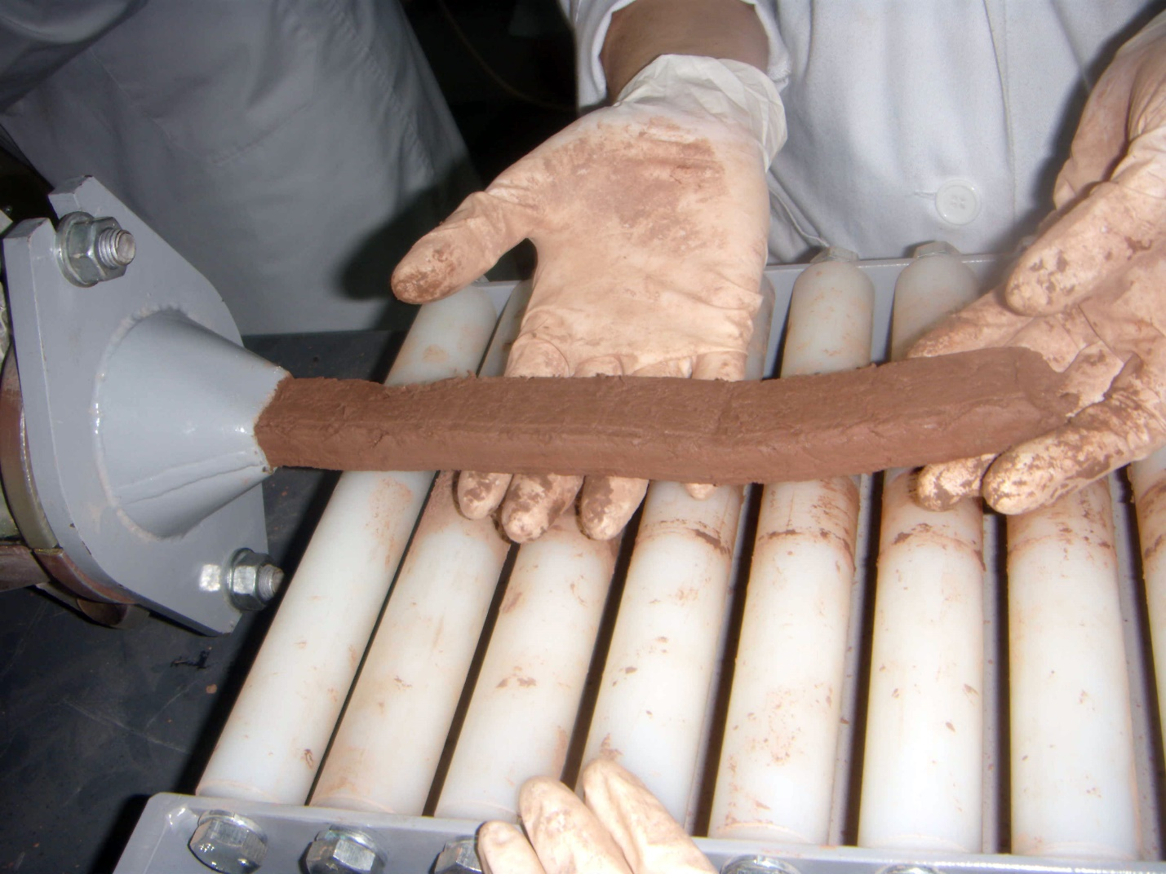ALIGARH:  The Aligarh Municipal Corporation and a waste management company is making 'eco-friendly' bricks, made from garbage, concrete and cement. These bricks are prepared in Meerut.  
  
This idea of the 'eco-friendly' bricks was presented to Uttar Pradesh Chief Minister Yogi Adityanath last year by a private waste management firm.  
  
"Bricks prepared in our plant in Meerut have been used in Lucknow and Gurgaon, with the recent passing of the proposal in the municipal board, this magic bricks will be used in more areas now. A single brick weighs 17 kilogram and is worth Rs. 35," project head Sam Singh told ANI.

The authorities are looking at ways to decrease the weight of the bricks for better results.

"These bricks are eco-friendly. We are utilising the waste100 per cent to make them. For our efforts, we have been chosen for an award at Swachh Survekshan 2018 Awards," Municipal Commissioner Satya Prakash Patel said.

# 34. “Plant Lamps” Turn Dirt and Vegetation into a Power Source

## Researchers in Peru have a new way to capture electricity from plants and bacteria to help rainforest communities.

**R**esearchers at the [Universidad de Ingeniería y Tecnología](https://www.youtube.com/channel/UCZFYiL8WGV95dG92ZAxx_vQ)(UTEC) have developed a technique for capturing the electricity emitted from plants. Actually, to be fair, it’s Geobacter— a genus of bacteria that live in the soil — that do the grunt work. [Robby Berman at Slate](http://www.slate.com/articles/video/video/2015/11/utec_generates_electricity_for_rainforest_villages_from_plants_and_dirt.html) explains the process:

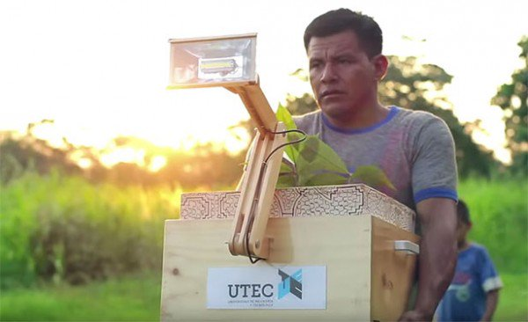A lamp

“[N]utrients in plants encounter microorganisms called ‘[geobacters](http://schaechter.asmblog.org/schaechter/2011/03/geobacter-microbial-superhero.html" \t "_blank)’ in the dirt, and that process releases electrons that electrodes in the dirt can capture. A grid of these electrodes can transfer the electrons into a standard battery.”

UTEC has partnered with global ad agency FCB to produce 10 prototypes and distribute them to houses in the rainforest village of Nuevo Saposoa. Each contains an electrode grid buried in dirt, in which a single plant grows. The grid connects to a battery, which powers a large LED lamp attached to an adjustable arm on the outside of the box. The UTEC video below shows the boxes in action (including a money shot of a lamp being triumphantly turned on):

For Nuevo Saposoa and other underserved communities, this is more than just a crackerjack bit of biological engineering. Electricity, and lighting in particular, are a very real need. Berman writes:

“In the rainforest villages of Nuevo Saposoa and Pucallpa in Perù, there’s an existing electrical grid, but since a flood last March damaged its cables, it hasn’t been working. Forty-two percent of the communities in the rainforest don’t have even that much. Sundown means lights out, a real problem for families with small children—and for students who need to study—unless they resort to [unhealthy and dangerous kerosene lamps](http://www.bbc.com/news/business-18262217).”

UTEC has a tradition of this sort of humanitarian innovation, Berman explains. “A while back, [it found a way](http://www.upworthy.com/the-water-on-the-grounds-too-nasty-for-farming-so-theyre-growing-crops-in-the-air) of growing plants on platforms using clean moisture pulled from the air in a region whose groundwater—and ground—has been ruined by pollution.”

If the “plant lamps” (that’s UTEC’s name, not mine) are successful, their appeal isn’t going to be limited to rainforest communities. Who wouldn’t want a houseplant that cut back on their electric bill? Add a bit of green to your bank account and your bedroom.

It’s worth noting that UTEC’s researchers are hardly the first to make use of Geobacter — they’re some of biotech’s most talented microbes. In [2009 Time named the “electric microbe”](http://content.time.com/time/specials/packages/article/0,28804,1934027_1934003_1933965,00.html) one of its 50 best inventions of the year. Recent research confirms they’re electrically conductive to boot, which means in theory they can [act like nanowires](http://phys.org/news/2015-03-theory-debate-microbial-nanowires.html) for transmitting electricity. In addition to power generation, Geobacter have also garnered attention for their ability to metabolize pollution like [radioactive material](http://news.discovery.com/tech/biotechnology/how-bacteria-clean-up-nuclear-waste-110909.htm).

As elegant as the plant lamps are, it’s easy to imagine even bigger and better applications. What sort of power could an entire garden generate? Is there a way to combine pollution-tolerant plants with the electric grid and bacteria — might a grove of trees help reduce soil pollution and provide power?

Moving forward, it strikes me that ethos of the “plant lamp” is the perfect balm for those of us chafing at the more aggressively capitalistic and controlling approach of the Big Bads of biotech (i.e. Monsanto). UTEC’s plant lamps are an example of using technology to bring people into more mutually beneficial relationships with biology and to solve local problems. It’s symbiosis.

# 35. This Ingenious Machine Turns Feces Into Drinking Water

| January 5, 2015

I watched the piles of feces go up the conveyer belt and drop into a large bin. They made their way through the machine, getting boiled and treated. A few minutes later I took a long taste of the end result: a glass of delicious drinking water.

The occasion was a tour of a facility that burns human waste and produces water and electricity (plus a little ash). I have visited lots of similar sites, like power plants and paper mills, so when I heard about this one—it’s part of the Gates Foundation’s effort to improve sanitation in poor countries—I was eager to check it out.

The water tasted as good as any I’ve had out of a bottle. And having studied the engineering behind it, I would happily drink it every day. It’s that safe.

Here’s a short video from my visit in November, which explains how it all works:

Why would anyone want to turn waste into drinking water and electricity?

Because a shocking number of people, at least 2 billion, use latrines that aren’t properly drained. Others simply defecate out in the open. The waste contaminates drinking water for millions of people, with horrific consequences: Diseases caused by poor sanitation kill some 700,000 children every year, and they prevent many more from fully developing mentally and physically.

If we can develop safe, affordable ways to get rid of human waste, we can prevent many of those deaths and help more children grow up healthy.

Western toilets aren’t the answer, because they require a massive infrastructure of sewer lines and treatment plants that just isn’t feasible in many poor countries. So a few years ago our foundation put out a call for new solution.

One idea is to reinvent the toilet, which I’ve [written about before](https://www.gatesnotes.com/Development/Reflections-on-the-Reinvent-the-Toilet-Challenge).

Another idea—and the goal of the project I toured—is to reinvent the sewage treatment plant. The project is called the Omniprocessor, and it was designed and built by Janicki Bioenergy, an engineering firm based north of Seattle. I recently went to Janicki’s headquarters to check out an Omniprocessor before the start of a pilot project in Senegal.

The Omniprocessor is a safe repository for human waste. Today, in many places without modern sewage systems, truckers take the waste from latrines and dump it into the nearest river or the ocean—or at a treatment facility that doesn’t actually treat the sewage. Either way, it often ends up in the water supply. If they took it to the Omniprocessor instead, it would be burned safely. The machine runs at such a high temperature (1000 degrees Celsius) that there’s no nasty smell; in fact it meets all the emissions standards set by the U.S. government.

Before we even started the tour, I had a question: Don’t modern sewage plants already incinerate waste? I learned that some just turn the waste into solids that are stored in the desert. Others burn it using diesel or some other fuel that they buy. That means they use a lot of energy, which makes them impractical in most poor countries.

The Omniprocessor solves that problem. Through the ingenious use of a steam engine, it produces more than enough energy to burn the next batch of waste. In other words, it powers itself, with electricity to spare. The next-generation processor, more advanced than the one I saw, will handle waste from 100,000 people, producing up to 86,000 liters of potable water a day and a net 250 kw of electricity.

If we get it right, it will be a good example of how philanthropy can provide seed money that draws bright people to work on big problems, eventually creating a self-supporting industry. Our foundation is funding Janicki to do the development. It’s really amazing to see how they’ve embraced the work; founder Peter Janicki and his family have traveled to Africa and India multiple times so they can see the scope of the problem. Our goal is to make the processors cheap enough that entrepreneurs in low- and middle-income countries will want to invest in them and then start profitable waste-treatment businesses.

We still have a lot to learn before we get to that point. The next step is the pilot project; later this year, Janicki will set up an Omniprocessor in Dakar, Senegal, where they’ll study everything from how you connect with the local community (the team is already working with leaders there) to how you pick the most convenient location. They will also test one of the coolest things I saw on my tour: a system of sensors and webcams that will let Janicki’s engineers control the processor remotely and communicate with the team in Dakar so they can diagnose any problems that come up.

The history of philanthropy is littered with well-intentioned inventions that never deliver on their promise. Hopefully, these early steps will help us make sure the Omniprocessor doesn’t join the list. If things go well in Senegal, we’ll start looking for partners in the developing world. For example I think it could be a great fit in India, where there are lots of entrepreneurs who could own and operate the processors, as well as companies with the skill to manufacture many of the parts.

It might be many years before the processor is being used widely. But I was really impressed with Janicki’s engineering. And I’m excited about the business model. The processor wouldn’t just keep human waste out of the drinking water; it would turn waste into a commodity with real value in the marketplace. It’s the ultimate example of that old expression: one man’s trash is another man’s treasure.

# 36.Karnataka Students’ Innovation Uses Rainwater to Generate Electricity From Highways!

## f this brilliant idea becomes a reality, your road trips could literally power street lights in villages. How cool is that! #Innovation #GreenIndia

by **[Rinchen Norbu Wangchuk](https://www.thebetterindia.com/author/rinchen-norbu-wangchuk/" \o "Posts by Rinchen Norbu Wangchuk)**November 24, 2018, 3:10 pm

Despite the Indian education system’s unfortunate emphasis on rote learning, students across educational institutions in India continue to come up with innovative solutions to real life problems. Since its inception, The Better India has sought to highlight these innovations that sometimes manage to attract the upper echelons of this country’s governance structure.

Thanks to two students of Civil Engineering from the KCE Society’s CI Munavalli Polytechnic College based out of Hubbali (also known as Hubli) in Karnataka state, an innovation which can generate electricity from moving vehicles on the highways and rainwater, besides recharging water bodies, has come to light.

The project titled ‘Strategies for enhancing local water bodies with the production of electricity through water and Enlil turbines’ won Pruthviraj S Sarangmath and Prasanna Kalkoti, who are final-year engineering students, the first prize in the Indian International Science Festival in Lucknow, which was held last month.

So, what is an Enlil turbine? It is originally a vertical axis wind turbine that generates electricity from wind power.

How does it work?

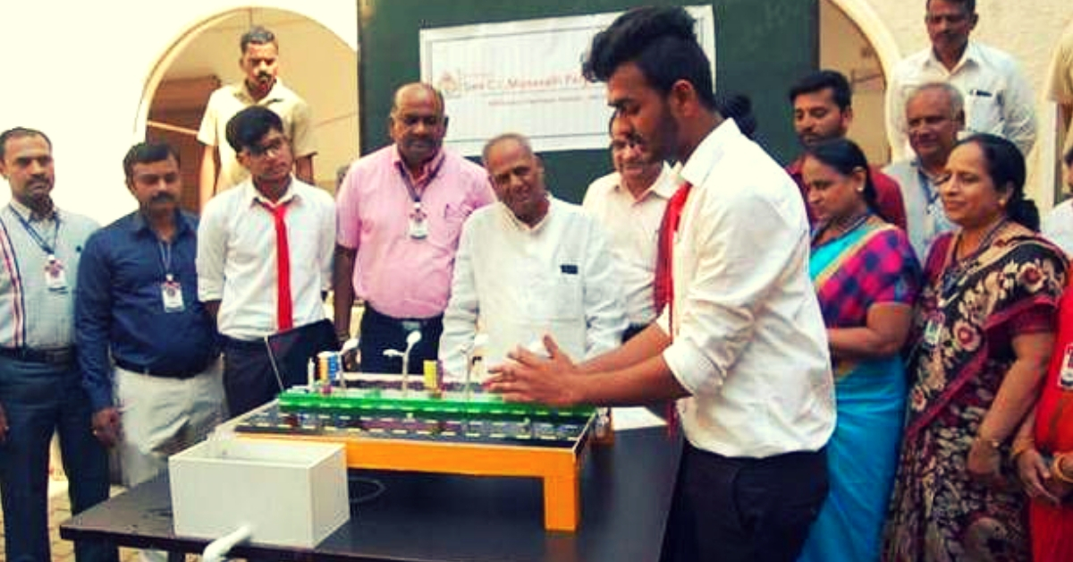Students from KLE Society’s C I Munavalli Polytechnic College in Hubballi have come up with a way to generate electricity from moving vehicles. (Source: [Facebook](https://www.facebook.com/hubballiedition/photos/basw.Abq8FOhQ1us6WgXjrLlAfEfYSwIl9IiDFRizUPliUK1bYjJrUpC_C9OcadT__gZ-Lo6ZxVJHhKR1lXAvWK8kosxNR4ROwbMI7O6eQsrQDFnzywzOc2FsPgNm_Lsw48fSCjRSOXpvVCNGh-RNnpzEYP97hg05YvxcPakvy-UPoB3fd7Xf7tXdidzTtDEhb0Qh-Ks.2120323324644665.197421090722217.1552959014799769.1396557687075507.810552239038125.813747358637209.810552232371459.1396557780408831.896688984053974/896688984053974/?type=1&opaqueCursor=AbqTKm83ZYrx3YPW4svFRXxqO1dmxhlUCYEorM5QPEm0uvyIvW3flN2hJ6utn-55rD3c-Ztn9_VIXdWnf2pHADapb0zXAjanXXgXOFMFXMqH3D7Ui5aDtDMp4Ueww11QECAN-yFGMlx6-NyFSYlrmq-0i8EvZXVCswXClE-TmyFgAkVnedloppLqcbXuCqT0qKYU4V1cZ2FHDtftjzR262tD39gsww6dV0whuOC3aGva7zzfil2gCkJcqnNCNDflEHSNsR6RyQa0-Lrg6jq0P0l3qgUWRskx7Du7v-Z9LuOAslPa3ebtZri--k8fGOfM9vHprlVxIHwFt0YPxbcPQH9WGT0DVvnp-CWZfZO_WizDELK5YnZmlpuOx4oKAurwJ89DtGiga6pbaeGBSBmuhszkmpzo2DwHtXoKf3V1G1s6EVXQp5z7Lc-zX3DVRezzy4qtTib9pTvVax-LTvDtrTsfO3ZBGiTL0MOHPoY3fJiEBHRahvU5jzAF9iX8fpVnhvBOqLJr294MTFYOjnqg08r1PEWUfWqt625R6ZfsHZdTV18p7fxYsnwoSGNjMEOwYLP6cW8El0NKlcRb2TyDgfKsRfiN8Be-lQopYULcnFwOIQ&theater" \t "_blank))

“The turbine works on wind power. These are vertical axis turbines, and when wind passes through them, it turns in a circular motion due to which electric energy is produced. The best place for the implementation of Enlil turbines is on highways or roads where vehicular traffic is more. Due to the movement of vehicles, the turbines will start rotating and thus produce power. These turbines can produce 1KW power per hour, which can be stored and later used to power street lights and also provided to nearby villages,” says Pruthviraj, in a conversation with **[Edexlive](http://www.newindianexpress.com/states/karnataka/2018/nov/21/these-huballi-students-can-generate-electricity-from-moving-vehicles-and-rainwater-1901397.html" \t "_blank)**.

According to the students, one turbine can generate up to 1 kW of power per hour serving the electricity requirement of two households, reports **[The Hindu](https://www.thehindu.com/news/national/karnataka/hubballi-students-develop-way-to-generate-electricity-from-rainwater-running-on-roads/article25214128.ece" \t "_blank)**.

Meanwhile, this award-winning innovation from Karnataka also ensures that surface run-off water (rainwater) does not merely end up in drains, but through the process of slow sand filtration help recharge water waterbodies, generate drinking water and further electricity.

**Also Read: [Exclusive: Meet India’s First Startup That Can Switch Your Car From Fossil Fuel to Electric!](https://www.thebetterindia.com/164591/electric-vehicle-e-trio-hyderabad-news/" \t "_blank)**

“The rainwater run-off has increased, and groundwater recharge has declined. As the roads are built sloped towards the sides, rainwater falling on the road is guided to the side drains. The rainwater which is then collected from the drain is made to fall from a certain height into the tanks that help to produce a certain amount of electricity through dynamo and stored for use later,” adds Pruthviraj.

Both students were ably guided by Nagraj Ganachari and Akshya Vastrad, two professors in the varsity’s Civil Engineering department This Karnataka student project that won the IISC Festival over 100 such entries in Lucknow was judged by a jury of 11 faculty members from IIT Delhi, NIT Suratkal and MNIT Jaipur.

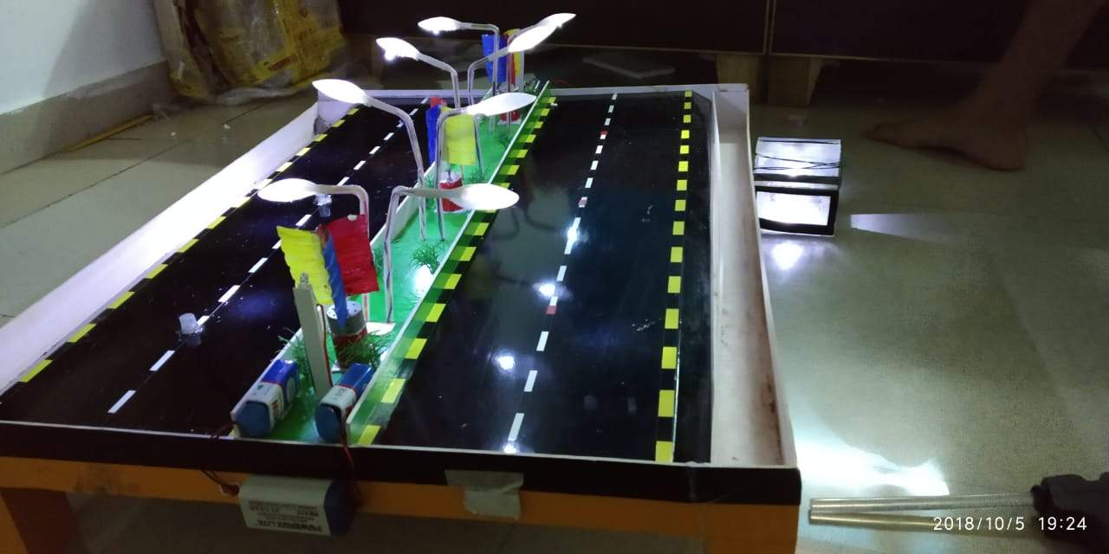

"The rainwater run-off has increased and groundwater recharge has declined. As the roads are built sloped towards the sides, rainwater falling on the road is guided to the side drains. The rainwater which is then collected from the drain is made to fall from a certain height into the tanks that help to produce a certain amount of electricity through dynamo and stored for use later."  
  
The two students completed their first prototype of the project with the help and guidance of faculty members Nagraj Ganachari and Akshya Vastrad. "We discussed the idea with them and they helped us throughout with the production process. Our HOD Vijaya Patil and our principal Veeresh Angadi also supported us," adds Pruthviraj.

# 37.Worried About Polluting Plastic Plates, Bowls? CHUK Has an Eco-Friendly Solution!

## You can use these cost-efficient containers instead and avoid polluting the environment

Look around, and you will see a world filled with plastic, a material that will not decompose for the next 500 years. Plastic is everywhere, and it promises to stay around for a while. Ved Krishna was troubled by this very thought and decided to change things for his paper company.

Ved inherited Yash Papers his family-run paper business in 1999. The company manufactured pharmaceutical papers, paper bags for food chains like McDonalds and sugar sachets for coffee chains like Café Coffee Day.

In 2009, Ved had an epiphany about the amount of garbage his factory was indirectly generating. He realised that most of the paper manufactured by the company was covered in plastic, cellophane or was laminated, and would not decompose for the next few centuries. That acted as a turning point in his career and marked the conception of [CHUK](https://www.chuk.in/index.php), a company that manufactures biodegradable tableware.

CHUK, which launched in 2017, makes products from agricultural residues.

## All the plates, bowl, containers and lids they manufacture are biodegradable while being efficient too. Their tableware is microwave, oven, and freezer friendly.

Biodegradable containers and bowls by [CHUK](https://www.chuk.in/products.php).

“Regarding manufacturing, we are aware that eco-friendly products do have their drawbacks when it comes to sealing the products, the risk of leakage etc. However, we have done extensive R&D and made necessary changes in our manufacturing process and technique to produce strong modular designs with quality that will be better than plastic,” Ved told [YourStory](https://yourstory.com/2017/12/paradise-biryani-foodpanda-chuk-brings-food-packaging-solutions/).

Chuk has now collaborated with big names in the food market like Vaango, Paradise Biryani Group, Bitto Tikka and Foodpanda.

## “After studying the market extensively, the company decided to keep the products brown, and untreated with chemicals,” says Ved.

A plate by [CHUK](https://www.chuk.in/products-trays.php).

“The products are more like Lego pieces, which fit into each other and have multiple uses. For example, the containers can be used as bowls or even trays.”

**You may also like: [Eat with It and Then Eat It – Meet the Man Who Introduced Edible Cutlery to the World](https://www.thebetterindia.com/30465/edible-cutlery-in-india/)**

In 1995, Yash Papers had already installed a power plant that generated electricity from rice husks. They are still the only compostable tableware manufacturer, who get all their electricity from bio-fuel. In 2007, Yash Papers bought an advanced pulp mill which made them the only pulp-to-product manufacturers of compostable tableware in the world!

“Chuk is a group of passionate individuals who believe that our everyday work can make a huge impact on our community,” says Ved.“50% of the new CHUK plant is staffed by village women, and some of them are specially-abled. You can do business and do good!”

# 38. Recycle Plastic Bottles in This Machine, and It Will Dispense Food for Stray Dogs

In Istanbul, Turkey, where an [estimated 150,000](http://latitude.blogs.nytimes.com/2012/10/04/against-a-bill-to-cull-stray-animals-in-turkeys-cities/?_php=true&_type=blogs&_r=0) stray dogs and cats reportedly wander the streets, a Turkish company called Pugedon believes it has come up with a way to feed the animals: “Smart Recycling Boxes,” a machine that dispenses food and water [in exchange for recycled plastic bottles](http://bigthink.com/design-for-good/recylce-bin-turns-bottles-into-food-for-stray-animals-and-provokes-our-humanity), Big Think reports.

The benefits of the vending machine are supposed to be two fold: encourage recycling and feed the city’s strays. Recycling is put on top and food is dispensed out the bottom within easy reach for animals in need. There’s even a water dish attached so users can pour the remaining water from a plastic bottle before recycling it. The recycled bottles are supposed to cover the cost of the food.

# 39.Cleansebot: Tiny Bed Cleaning Robot Kills Bacteria In Bed-sheet

[](https://odditymall.com/includes/content/cleansebot-tiny-bed-cleaning-robot-kills-bacteria-in-bed-sheets-0.gif)

[Tweet](https://twitter.com/share)

Much like how a [Roomba](https://www.amazon.com/s/ref=nb_sb_noss?url=search-alias%3Daps&field-keywords=roomba&tag=om-inco-20) will automatically vacuum your floors, the [WinBot](https://www.amazon.com/s/ref=nb_sb_noss?url=search-alias%3Dgarden&field-keywords=winbot&tag=om-inco-20" \t "_blank) will automatically clean your windows, the [Solar Breeze](https://www.amazon.com/Solar-Breeze-NX2-robotic-solar-cleaner/dp/B079DFX9PD/?tag=om-inco-20) will automatically clean your pool, and the [GrillBot](https://www.amazon.com/exec/obidos/ASIN/B00HVP1O7U/om-list-20/" \t "_blank) will automatically clean your grill, the [Cleansebot](https://www.kickstarter.com/projects/cleansebot/worlds-first-bacteria-killing-robot" \t "_blank) is a new robot that will automatically clean your sheets and kill the bacteria hiding in them.

Perfect for traveling and staying in hotels and AirBnBs, the Cleansebot will ensure the beds you sleep in are bacteria free before you hop in and inside of it for 8 hours. Often times people get sick from the bacteria in dirty beds and pillows that they stay in while traveling. No longer will this be the case if you use this unique bed cleaning robot.



How it works is, the Cleansebot will disinfect and sanitize all hotel surfaces and the UV-C lights on the robot will help prevent the spread of airborne viruses. The robot is filled with 18 sensors, and uses 4 UV-C lamps to blast away 99.9% of germs and bacteria on any surface, but most importantly on your hotel bed.



To use it, just place the bed cleaning robot on your bed, and turn it on. It will then run around on your bed like a Roomba, and clean and sanitize for either 30 or 60 minutes (depending on settings). You can set it and forget it while it does its job under and over your sheets and bedspread.

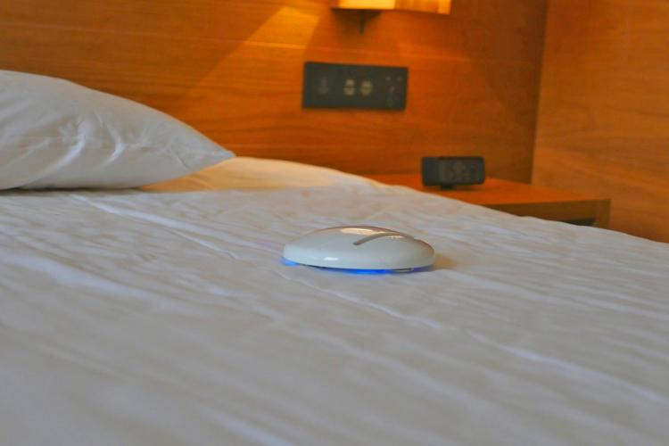

The Cleansebot is super tiny so it easily fits into a bag, purse, or piece of luggage to use and bring with you when you need it the most. The bed Roomba has an internal 3700 mAh rechargeable battery that can run for 3 hours per charge, and takes 4 hours to fully recharge.

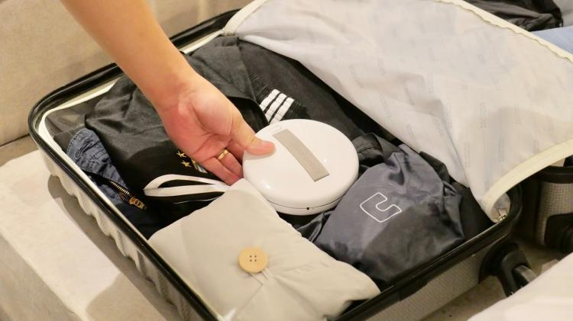

Check out the Cleansebot bed cleaning robot in action via the video below.

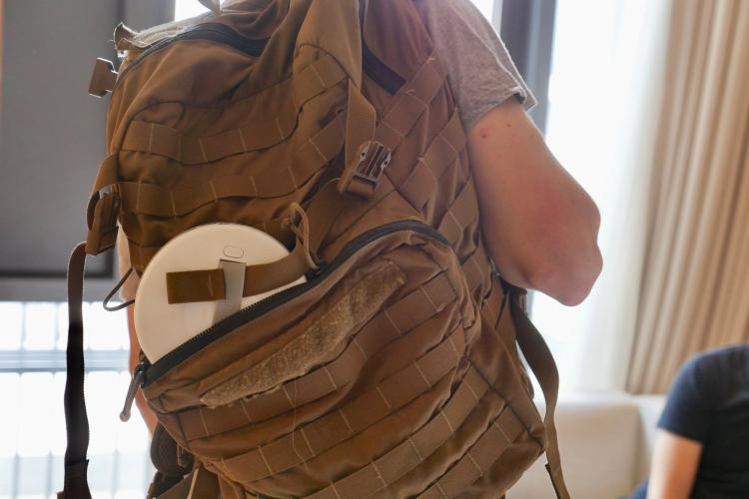

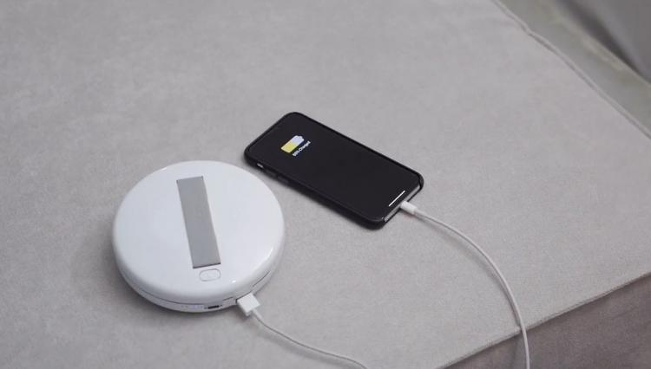

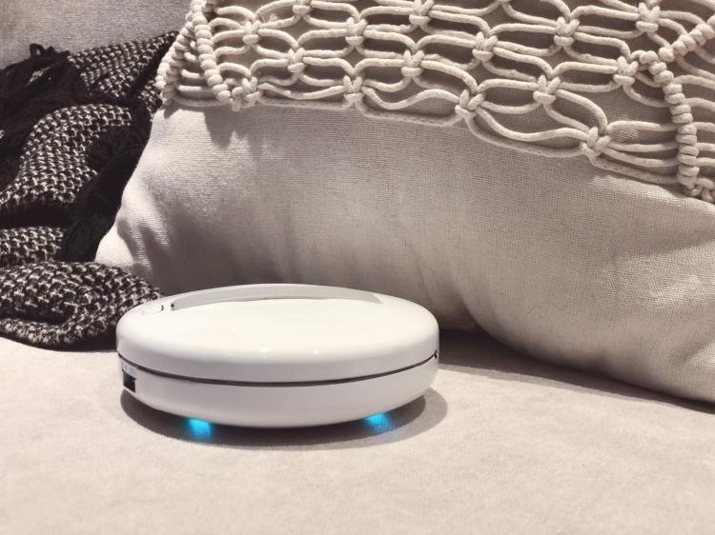

# 40. 4 African girls have created a generator that produces Electricity for 6 hours using a single liter of urine as fuel:

Did you ever think someone could use urine as fuel? These four African students did their best to prove their theory right and discover something incredible from their intelligence.

This is surely going to be of interest to each and every individual – four teenage girls found a way to use one liter of urine as fuel. They used urine in their generator and noticed electricity for six hours. To your surprise, three of them are only fourteen years old and their names are Duro-Aina Adebola, Akindele Abiola, and Faleke Oluwatoyin; the fourth one is the fifteen years old Bello Eniola. All the four girls proudly displayed their invention at Maker Faire Africa in Lagos, Nigeria; this is an annual event hosted for all those with creative brains.

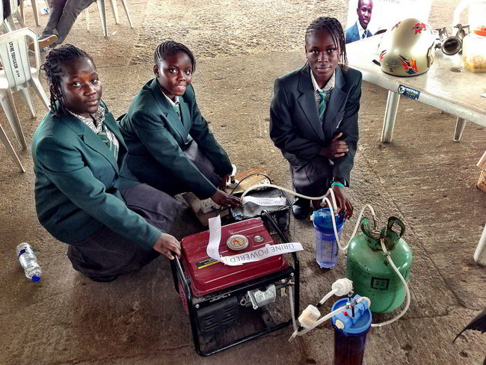

forbes

#### Here is how the generator words:

Urine is poured into an electrolytic cell that forces the separation of hydrogen, which goes into a filter for the sake of purification. The purified hydrogen reaches the gas cylinder that has liquid borax; this removes the moisture from the collected gas. Pure hydrogen is pushed into the generator, which then gives birth to electricity.

#### Is this a new idea?

The thought of using urine as an electricity producer is not new; however, the girls have put the thoughts into reality. The most wonderful thing about the process invented by them is that they have used all stuff that can be found easily at home.

Urine waste is too much on a daily basis, since it is natural. The thought and creation of the four girls is quite splendid for it is an elegant way to use the urine waste. Of course you have to put more energy to get the process working, but their idea can be used on a larger scale someday.

# 41. Meet the 17-Year-Old Boy From Telangana Who Invented a Unique Device to Prevent Rape

## Fuelled by the protests following the Nirbhaya rape case, 15-year-old Siddharth Mandala came up with an invention to stop further incidents of rape – the ElectroShoe.

by [**Guest Contributor**](https://www.thebetterindia.com/author/guest-contributor/)May 18, 2017, 5:14 pm

I was 12 years old when the Delhi rape incident took place. I remember my mom joining the march for the Nirbhaya (meaning fearless) campaign with 500 people for several weeks to support the victim and her family. Curious about the protest, I asked my mom if I could come along one day.

Soon, I started attending the protests every weekend. The more often I went, the more enraged I felt. What if the victim had been my mother? What if she had been one of my friends? On most days, I would stay there for seven straight hours on just three slices of bread, my hunger satiated by my purpose of being there.

As time went by, I realised that it is not rape that hurt the victims most, but rather society which looks down upon them. They are looked upon with pity. They are told that there is no coming back from the incident.

For three months I protested, waiting for justice for Nirbhaya and thousands of other nameless victims. Frustrated that the judicial system moved at a snail’s pace, at the age of 15, I decided to do something myself.I used my own knowledge and the Internet, and with my friend Abhishek’s help, I made something that could stop people becoming victims of rape.

[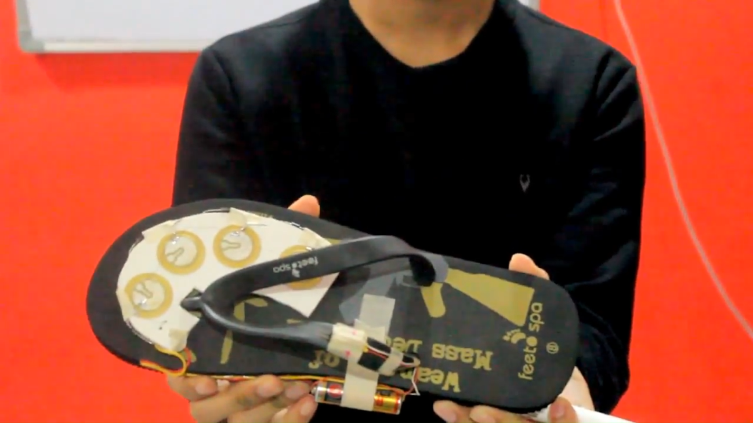](https://www.thebetterindia.com/wp-content/uploads/2017/05/Screenshot_7.png)The ElectroShoe prototype

I invented a patent-pending device called ElectroShoe. It can electrocute the perpetrator instantly by inflicting 0.1 Ampere of electricity, while sending an alert for assistance to cops and family members. To accomplish this, I created a unique circuit board that uses footsteps to charge itself with the help of a concept called the “piezoelectric effect” which I learned in my physics class. The more the user walks, the more energy is generated and stored in a rechargeable battery.

**You might also like:**[This Corporate Professional Quit his Job to Ensure that Nobody in his City Goes Hungry or Homeless](https://www.thebetterindia.com/82640/hyderabad-ngo-homeless-children-senior-citizen/)

The invention process was an uphill climb as I ran into countless problems. With the help of many great mentors from LinkedIn and social media, I taught myself programming in various languages. I would spam them every time my code didn’t work. Fed up, some of them even stopped replying. My prototype failed 17 times. While experimenting, I faced electrocution twice, and my friend Abhishek even developed a nosebleed.

But whenever I felt like giving up, I remembered my favourite inventor Thomas Edison’s words, “I didn’t fail 1,000 times. The light-bulb was an invention with 1,000 steps.”

It took me two years to build a working prototype. In the end, the hard work paid off and I was able to create a working prototype of the shoe. I felt like a superhero. It felt amazing to know that if this product could reach the people, I might be able to save at least a few lives.

## Because of my efforts, the Education Minister and Deputy Chief Minister of Telangana, Kadiyam Srihari, awarded me with a letter of appreciation.

[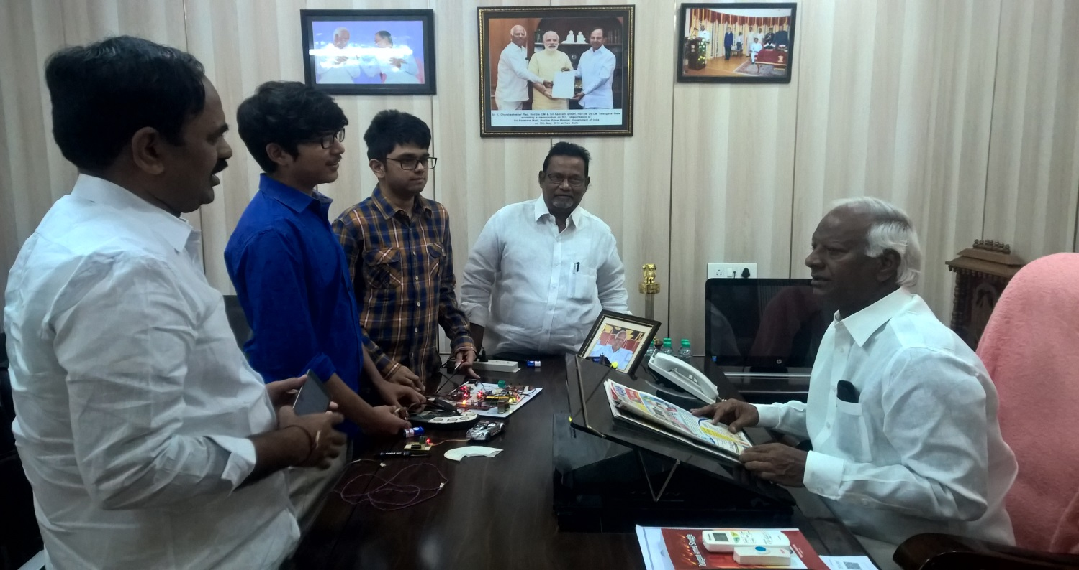](https://www.thebetterindia.com/wp-content/uploads/2017/05/WP_20161125_10_03_52_Pro.jpg)Explaining the ElectroShoe concept to Kadiyam Srihari.

While working on this product, I also became an “activist”, influenced by my mother. I started an NGO called [Cognizance Welfare Initiative (CWI)](http://www.cognizancewelfareinitiative.in/" \t "_blank) to spread awareness about rape. I also taught basic coding to government school children, and helped them build their own projects dealing with micro-controllers. My team and I also filled over 30 potholes in and around Hyderabad with the renowned social worker Gangadhar Tilak, popularly known as “pothole man”. Because of our efforts, we were [covered by the BBC](http://www.bbc.com/hindi/india/2016/04/160417_unsung_indians_kg_tilak_pk?ocid=wshindi..ppc.sponsored-tweet.facebook.UnsungIndians.PotholesMale.Post1.mktg" \t "_blank).

We donated bags, books, pens and others items of stationery to over 500 students for their board examinations. CWI started with five people, but after the BBC article, we ended up with more than 40 volunteers.

**You might also like:**[This Engineering Student Has Made a Portable Water Purifier. And It Costs Just ₹ 20](https://www.thebetterindia.com/84515/engineering-student-nirnal-water-filter/)

I was eventually approached by USA-based organisation [Empower & Excel](http://empowerexcel.org/" \t "_blank) to be a part of their Indian Youth Wing as a team leader. They planned to expand in India and were in the process of adopting a school the Khanigiri village. Empower & Excel asked me to lead their tasks from helping children build solid communication skills and improve their literature knowledge to building eco-friendly Ganeshas and conduct book drives.

# 42.This Engineering Student Has Made a Portable Water Purifier. And It Costs Just Rs 20

by **[Sohini Dey](https://www.thebetterindia.com/author/sohini/" \o "Posts by Sohini Dey)**January 31, 2017, 4:30 pm

Water may be one of the basic essentials of life, but access to clean drinking water remains a challenge for countless Indians. Pollution and rampant scarcity of this precious resource, coupled with expensive purification systems, makes safe drinking water difficult to avail. But a cost-effective solution is afoot in Karnataka and it promises to make drinking water available to everyone.

## Niranjan Karagi, an engineering student from the state’s Belgaum district, has developed Nirnal, a water purifier that costs a mere Rs. 20.

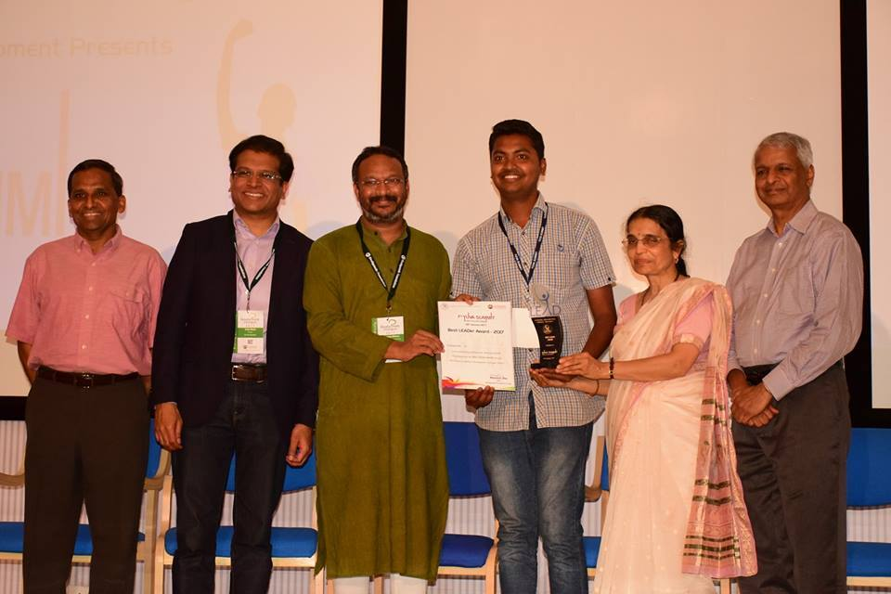Niranjan Karagi receiving an award for Nirnal

###### **IMAGE SOURCE:**[**FACEBOOK**](https://scontent.fblr2-1.fna.fbcdn.net/v/t1.0-9/16195117_581636058627643_4555867804019305311_n.jpg?oh=d3b26d85aa1f81c9873fbcf2b04555a1&oe=591877EC)

A final-year student of Angadi Institute of Technology & Management, Niranjan was motivated by the sight of children filling their empty plastic bottles with unpurified tap water near his home. He often created technologically-driven projects during his college days, and came up with the idea for a low-cost, portable water purifier.

“I filtered some water and sent it for preliminary testing,” Niranjan says. “The results were good.”

Feeling encouraged, Niranjan launched the product with support from Sandbox Startup, a business incubator, and Deshpande Foundation’s Leader Acceleration Development (LEAD) programme.

Nirnal is crafted from activated carbon, cotton, and mesh in a plastic-like covering. It fits easily inside small pet bottles, making it handy for travel.

Since its launch in 2016, Nirnal has sold over 7,000 units primarily among the region’s farmers, poor families, and in government schools and colleges. “Regular water filters are very expensive,” Niranjan says. “It was important for me to keep the pricing at a minimum so that the poor can buy it.”

Encouraged by business enquiries and positive feedback from customers, Niranjan is setting his goals high. “I want to reach out to the Karnataka government so that they can distribute it to school children for free, along with school supplies,” he says. Niranjan hopes that with the right support his initiative will ensure that everyone has clean water to drink.

# This Hyderabad boy designed electric shoes for women that will give molesters the shock of their lives

By: [FE Online](https://www.financialexpress.com/author/feonline/) | Updated: September 15, 2017 1:37 PM

## In a bid to make women capable of defending themselves, a 18-year-old boy from Hyderabad has designed a special shoe that will give assaulters an electric shock.

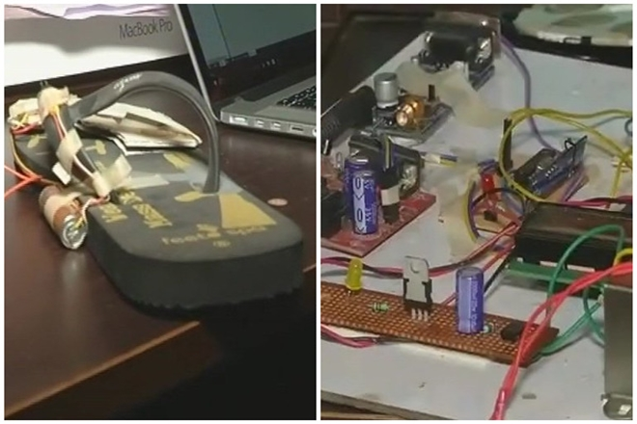

A 18-year-old boy from Hyderabad has designed a special shoe that will give assaulters an electric shock. (ANI)

In a bid to make women capable of defending themselves, a 18-year-old boy from Hyderabad has designed a special shoe that will give assaulters an electric shock. Siddharth Mandala, who made the electric shoe, said it will also send out an alert message to the nearby police station and family members when there is any danger. The shoe inflicts a 0.1 amp power shock. Mandala said, “All a woman needs to do is ensure that the battery is sufficiently charged. When the shoe makes contact with an attacker’s body, the attacker will be electrocuted,” as per the Times of India. He used the concept called the ‘piezoelectric effect’ while designing the shoe. A unique circuit board in the shoe uses footsteps to charge itself. “The more the user walks, the more energy is stored in the shoe’s rechargeable battery, ” he told TOI.

“I was 12 years old when the Delhi rape incident took place. I remember my mom joining the march for the Nirbhaya. Then I thought why I shouldn’t work on something productive rather than playing games, I have taken it as a challenge I thought it as a game. I explained my concept to my friend Abhishek and we started it. While testing it I got electric shocks and my friend also received an injury. But, keeping all aside we have made it successful,” Mandala was quoted as saying by ANI.  
The idea behind this shoe was was that it will be with woman every time because they can forget to carry pepper spray or electrical devices but they will surely wear footwear while moving out.

# 45. Ritu Sain IAS officer made her city as the Cleanest Smallest City of 2018

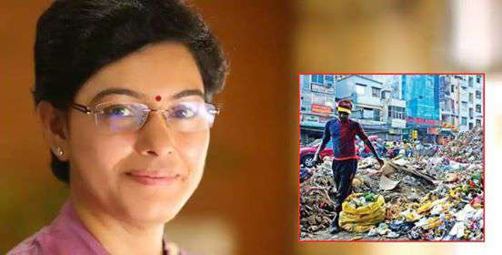

Ritu Sain, IAS officer who is not just a name but really proved an all-out effort to make her city as India's Cleanest Smallest City 2018. One such example was recently seen in Chhattisgarh's Ambikapur city in Surguja district where she turned the stinking place where survival was becoming tough to the cleanest town where people wish to live.

Ritu Sain, a 2003-batch Indian Administrative Service (IAS) officer, took the dare to change the city with her determination and dedication. She changed the picture of the town.

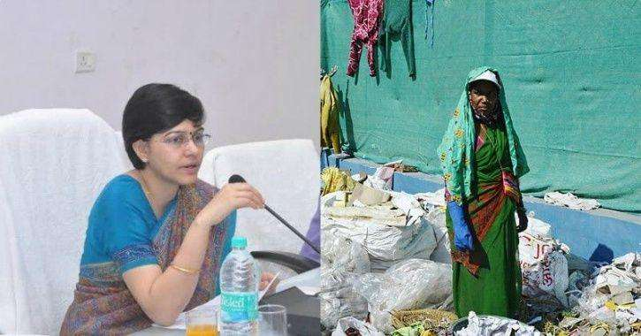

Courtesy   
In an interaction, she said, "There was a big signpost welcoming people to the municipal corporation of Ambikapur, and bang opposite that was a huge open dumping yard. The stink was unbearable. I thought to myself, what kind of impression the city would create if this was the first thing a person saw after entering."

Sain took charge of the city as a collector, she knew about the challenges. "There was no looking back since that day. I was clear about what I wanted to do," Sain, now Chhattisgarh's additional resident commissioner in Delhi, said.

Hindustan Times told, "It was a challenge. The city with a population of 1,45,000 had mere funds and hardly any capacity to take up the cleaning task. I knew whatever I did would have to be participatory, viable and replicable," Sain, who studied international relations from Delhi's Jawaharlal Nehru University.

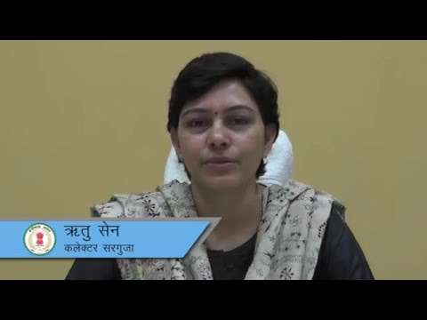

Courtesy

So after the deep thoughts and analysis of the root cause of the problem sain decided and laid a plan with strategies where she made the solid and liquid resource management model was started on a pilot basis in one ward, which was her inception towards cleanliness.

"It's a self-sustaining model. Each woman gets to earn Rs 5,000 per month from user fee and sale of recyclables. We have spent Rs 6 crore to put the entire infrastructure in place and have already earned Rs 2 crore. The money earned is being spent on the sanitation workers," Sain said.

"It's very fulfilling to see that something we started has come so far and is sustaining itself," she added.

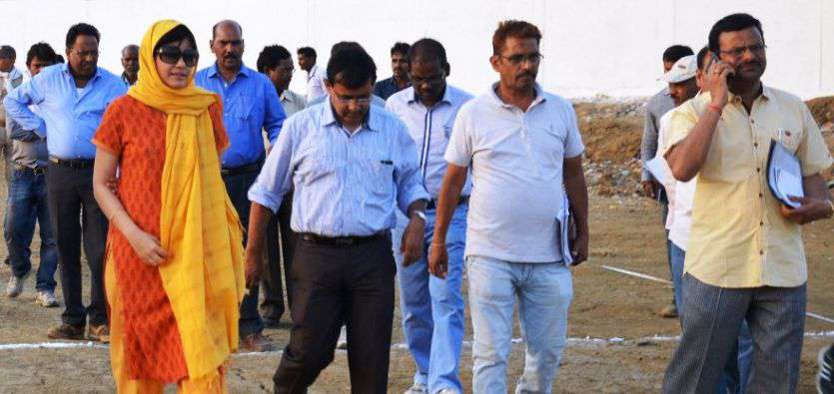

Courtesy

What're your views on this. don't you want to keep your city clean? Well, she is a true inspiration and a paragon for all of us.